

PERSONAL INFORMATION
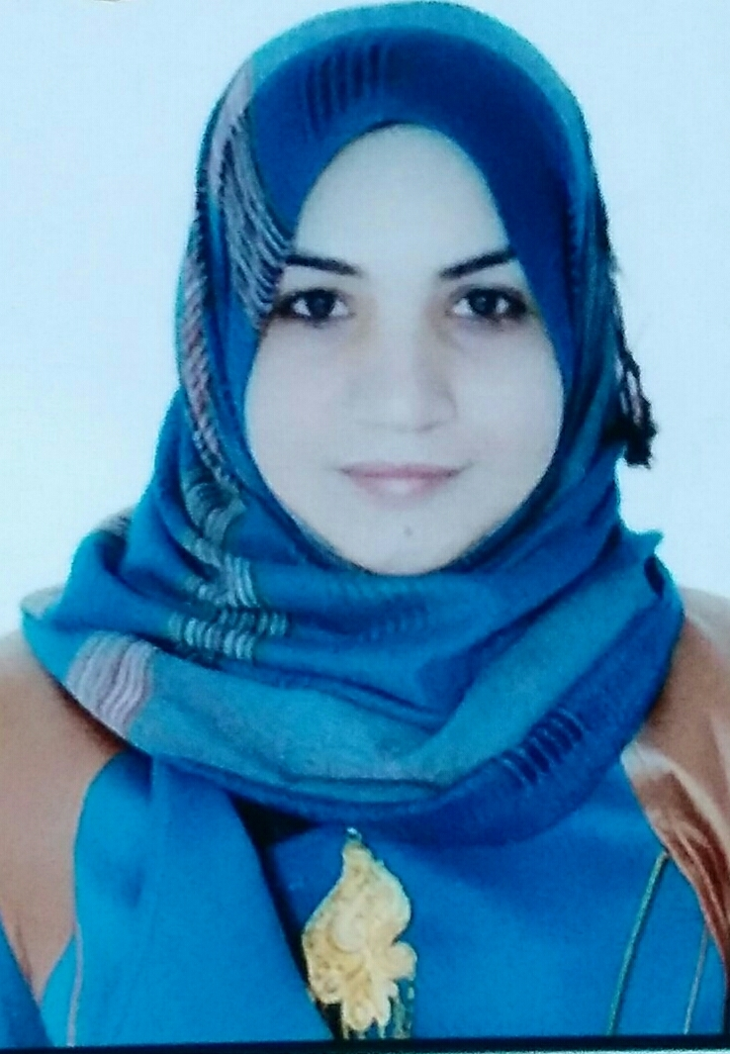
Name: ferial younes nazal .
Date of birth: 8/5/1984.
Place of birth: Thi-Qar, Nasiriyah
Social status: single .
Address: Thi-Qar, / Nasiriyah .
E-mail: ferial.nazal @yahoo.com.
Mobile No.: 0784128861
The Graduation year in Bachelor Stage: 2006/2005 College of Science , Thi_ Qar University.
The Graduation year in Master Stage: 2013/2012 College of Science , Al – Basrah University.
Occupational address: Lecturer.

SCIENTIFIC QUALIFICATION
Master Degree in Medical physics , College of Science, Al-Basrah University.

EXPERIENCE:
- I have two years training as a Physicist Assistant in the Lap of Medical Physics,Collage of Medicine , Thi-Qar University from 7/5/2007 to 1/10/2009.
- Now I teaching Medical Physics (theory & practice) in Department of Medical Physics, Collage of Medicine, Thi-Qar University.
- I got certificate of merit when I successfully completed training course in teaching methods held at College of Physical Education, Thi_ Qar University from 28/9/2014 to 19/10/2014.
- I got an efficiency certification in applications of computer and internal held at Thi-Qar University from 6/4/2014 to 20/4/2014 .
- Thankful : (30).
- Penalties: nothing
- The published researches = 6 with names
- Effect of Nuclear radiation on polyvinyl chloride .
- The effect of Gamma radiation on polyvinyl chloride and CN-85.
- The effect of Gamma ray doses on phagocytes Functional activity of Granulocytes by mean of Chemiluminescence .
- Effect of Ho-YAG Laser Therapy on Complete Blood Count for
Lithotripsy( In Vitro ) .
- The effect of He-Ne laser radiation and Temperature of blood in vitro on the Erythrocytes Sedimentation rate values in Healthy .
- A comparative study of High Level laser and Low Level laser and Temperature on the Erythrocytes Sedimentation rate values in Healthy people : in vitro study .

