- Risk factors of preeclampsia in patients attending Bint Alhuda hospital in Thi Qar 2018/2018

- Supervised by ; Doctor Enas Al khait

  - Student ; Sarah Zghair
  - Rasha Adnan

بسم الله الرحمن الرحيم
((قَالُوا سُبْحَانَكَ لَا عِلْمَ لَنَا إِلَّا مَا عَلَّمْتَنَا إِنَّكَ أَنْتَ الْعَلِيمُ الْحَكِيمُ))

(سورة البقرة: الآية 32)

Content
- Abstract
- Introduction
- Prevelance
- Method
- Result
- Discussion
- Conclusion

Abstract

This study was conducted to identify the risk factors of preeclampsia in patients attending Bint Alhuda hospital post off ward and emergency room In aperiod from 25 of September 2018 to the beginning of march 2019

Introduction

Preeclampsia is a multisystem syndrome that is primarily defined by the development of new-onset hypertension, persistent systolic blood pressure [SBP] of 140 mm Hg or higher, or diastolic blood pressure [DBP] of 90 mm Hg or higher after 20 weeks' gestation in a woman with previously normal blood pressure.Although preeclampsia is usually accompanied by new-onset proteinuria, the American Congress of Obstetrics and Gynecology (ACOG) recently revised the diagnostic criteria for preeclampsia so that the presence of proteinuria for diagnosis was no longer required, noting that elevated blood pressure accompanied by other signs and symptoms is sufficient for diagnosis. These other signs are also included in new terminology proposed by ACOG to identify cases with severe features.

Those severe features are: very high blood pressure, thrombocytopenia, renal insufficiency, impaired liver function, pulmonary edema, and cerebral or visual symptoms. The proportion of women who develop preeclampsia without proteinuria or who have proteinuria without hypertension preceding preeclampsia is unclear, with inconsistent definitions and approaches to measurement, and few studies examining these atypical presentations.Proteinuria levels among women diagnosed with preeclampsia, however, are not found to be consistently associated with adverse outcomes.

Pathophysiology of preeclampsia and eclampsia is poorly understood. Factors may include poorly developed uterine placental spiral arterioles (which decrease uteroplacental blood flow during late pregnancy), a genetic abnormality on chromosome 13, immunologic abnormalities, and placental ischemia or infarction. Lipid peroxidation of cell membranes induced by free radicals may contribute to preeclampsia.
Classification of hypertension in pregnancy

- Chronic hypertension ; preexisting hypertension presented prior to pregnancy
- Gestational hypertension: develope late in pregnancy after 20 weeks of pregnancy and resolve after 6 weeks after delivery it’s either 1_ gestational HT without proteinuria
- 2_proteinureia without HT 3_ gestational proteinuric HT( preeclampsia). 4_ eclampsia

Prevelance

Pre-eclampsia affects approximately 2–8% of all pregnancies worldwide,] The incidence of pre-eclampsia has risen in the U.S. since the 1990s, possibly as a result of increased prevalence of predisposing disorders, such as chronic hypertension, diabetes, and obesity

Pre-eclampsia is one of the leading causes of maternal and perinatal morbidity and mortality worldwide. Nearly one-tenth of all maternal deaths in Africa and Asia and one-quarter in Latin America are associated with hypertensive diseases in pregnancy, a category that encompasses pre-eclampsia

Methods

We conducted a retrospective analytical study Of the risk factors of pre-eclampsia in 100 patients who have pre-eclampsia
we took the ( Age,parity, gravida, misscareage, history of pre-eclampsia, history of gestational hypertension, history of chronic hypertension, history of DM, family history if pre-eclampsia, twin pregnancy,history of H mole, whether the couples are relative or not, occupation adress, history of renal disease or cardiac disease , history of smoking)

The data of all 100 patients Were analysed by using SPSS,version of 2007 Software and Microsoft Excel

age in year
 |  | Frequency | Percent | Valid Percent | Cumulative Percent
Valid | less than 20 | 12 | 12.0 | 12.0 | 12.0
 | 20 _less than 30 | 44 | 44.0 | 44.0 | 56.0
 | 30 -less than 40 | 33 | 33.0 | 33.0 | 89.0
 | above 40 | 11 | 11.0 | 11.0 | 100.0
 | Total | 100 | 100.0 | 100.0

parity
 |  | Frequency | Percent | Valid Percent | Cumulative Percent
Valid | primigravida | 26 | 26.0 | 26.0 | 26.0
 | multipara | 47 | 47.0 | 47.0 | 73.0
 | grandmultipara | 27 | 27.0 | 27.0 | 100.0
 | Total | 100 | 100.0 | 100.0

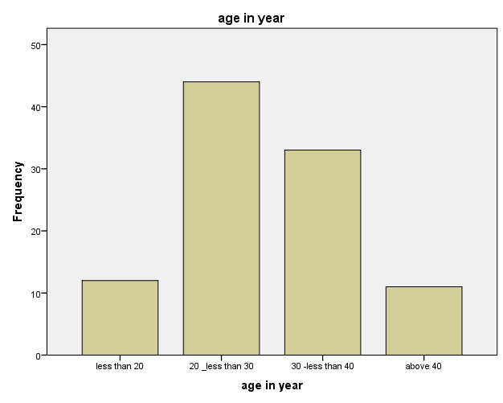
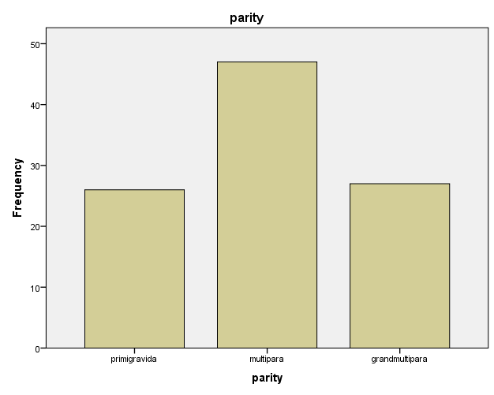

multiple pregnancy
 |  | Frequency | Percent | Valid Percent | Cumulative Percent
Valid | no | 87 | 87.0 | 87.0 | 87.0
 | yes | 13 | 13.0 | 13.0 | 100.0
 | Total | 100 | 100.0 | 100.0

miscarrige
 |  | Frequency | Percent | Valid Percent | Cumulative Percent
Valid | none | 70 | 70.0 | 70.0 | 70.0
 | early | 30 | 30.0 | 30.0 | 100.0
 | Total | 100 | 100.0 | 100.0

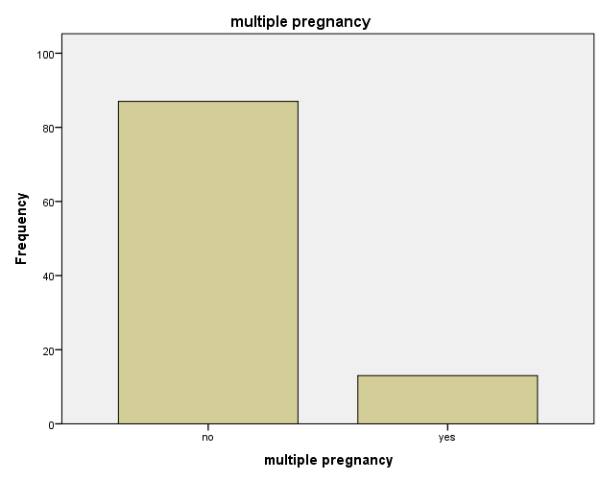

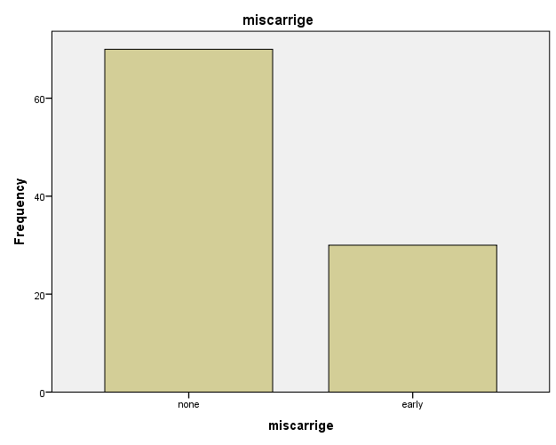

HX of H mole
 |  | Frequency | Percent | Valid Percent | Cumulative Percent
Valid | no | 94 | 94.0 | 94.0 | 94.0
 | yes | 6 | 6.0 | 6.0 | 100.0
 | Total | 100 | 100.0 | 100.0

Hx of preeclampsia
 |  | Frequency | Percent | Valid Percent | Cumulative Percent
Valid | no | 58 | 58.0 | 58.6 | 58.6
 | yes | 41 | 41.0 | 41.4 | 100.0
 | Total | 99 | 99.0 | 100.0
Missing | System | 1 | 1.0
Total |  | 100 | 100.0
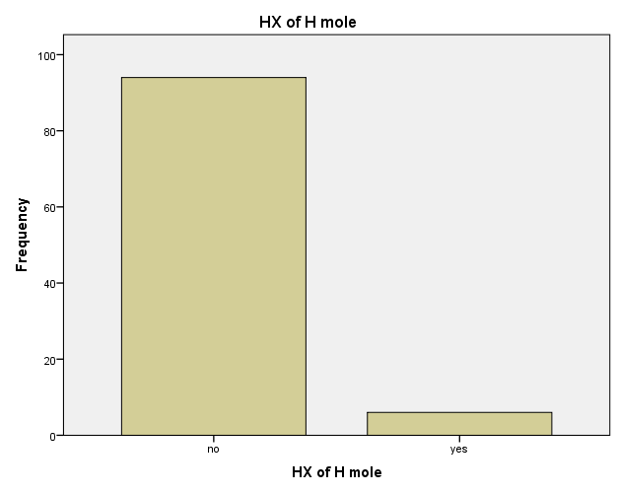
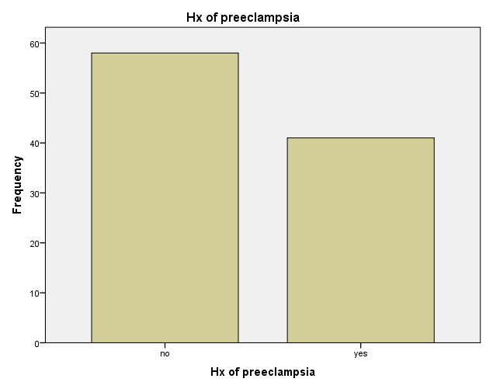

HX of abroptio placenta
 |  | Frequency | Percent | Valid Percent | Cumulative Percent
Valid | no | 86 | 86.0 | 86.0 | 86.0
 | yes | 14 | 14.0 | 14.0 | 100.0
 | Total | 100 | 100.0 | 100.0
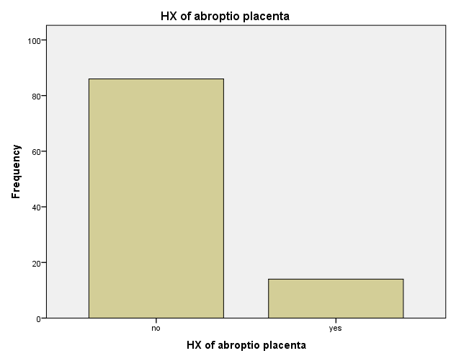

Family HX
 |  | Frequency | Percent | Valid Percent | Cumulative Percent
Valid | no | 74 | 74.0 | 74.0 | 74.0
 | yes | 26 | 26.0 | 26.0 | 100.0
 | Total | 100 | 100.0 | 100.0

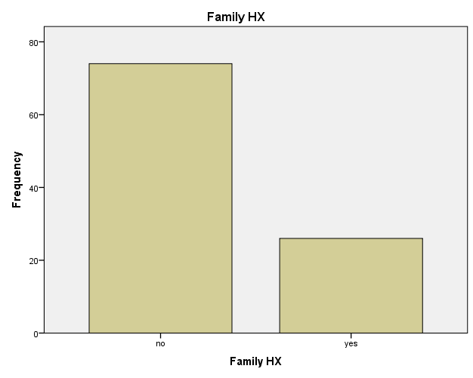

HX of abroptio placenta * parity Crosstabulation
 |  |  | parity |  |  | Total
 |  |  | primigravida | multipara | grandmultipara
HX of abroptio placenta | no | Count | 24 | 41 | 21 | 86
 |  | Expected Count | 22.4 | 40.4 | 23.2 | 86.0
 | yes | Count | 2 | 6 | 6 | 14
 |  | Expected Count | 3.6 | 6.6 | 3.8 | 14.0
Total |  | Count | 26 | 47 | 27 | 100
 |  | Expected Count | 26.0 | 47.0 | 27.0 | 100.0

Chi-Square Tests
 | Value | df | Asymptotic Significance (2-sided)
Pearson Chi-Square | 2.435ª | 2 | .296
Likelihood Ratio | 2.387 | 2 | .303
Linear-by-Linear Association | 2.312 | 1 | .128
N of Valid Cases | 100
a. 2 cells (33.3%) have expected count less than 5. The minimum expected count is 3.64.

HX of abroptio placenta * HX of H mole Crosstabulation
 |  |  | HX of H mole |  | Total
 |  |  | no | yes
HX of abroptio placenta | no | Count | 80 | 6 | 86
 |  | Expected Count | 80.8 | 5.2 | 86.0
 | yes | Count | 14 | 0 | 14
 |  | Expected Count | 13.2 | .8 | 14.0
Total |  | Count | 94 | 6 | 100
 |  | Expected Count | 94.0 | 6.0 | 100.0

Chi-Square Tests
 | Value | df | Asymptotic Significance (2-sided) | Exact Sig. (2-sided) | Exact Sig. (1-sided)
Pearson Chi-Square | 1.039ª | 1 | .308
Continuity Correction^{b} | .170 | 1 | .680
Likelihood Ratio | 1.871 | 1 | .171
Fisher's Exact Test |  |  |  | .591 | .394
Linear-by-Linear Association | 1.029 | 1 | .310
N of Valid Cases | 100
a. 1 cells (25.0%) have expected count less than 5. The minimum expected count is .84.
b. Computed only for a 2x2 table

HX of hypertention
 |  | Frequency | Percent | Valid Percent | Cumulative Percent
Valid | no | 49 | 49.0 | 49.0 | 49.0
 | chronic HT | 23 | 23.0 | 23.0 | 72.0
 | gestational HT | 28 | 28.0 | 28.0 | 100.0
 | Total | 100 | 100.0 | 100.0

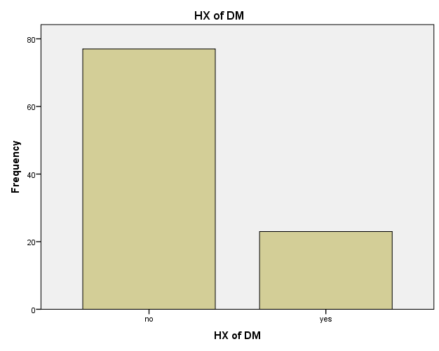

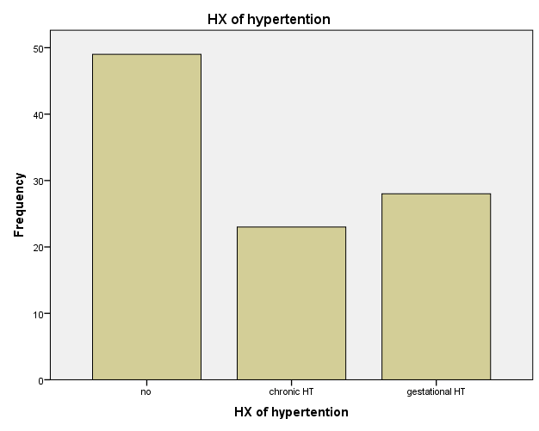

HX of contraceptive
 |  | Frequency | Percent | Valid Percent | Cumulative Percent
Valid | no | 43 | 43.0 | 43.0 | 43.0
 | yes | 57 | 57.0 | 57.0 | 100.0
 | Total | 100 | 100.0 | 100.0

Drug HX
 |  | Frequency | Percent | Valid Percent | Cumulative Percent
Valid | no | 56 | 56.0 | 56.0 | 56.0
 | yes | 44 | 44.0 | 44.0 | 100.0
 | Total | 100 | 100.0 | 100.0

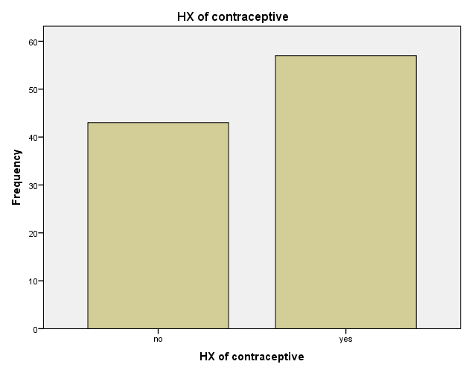

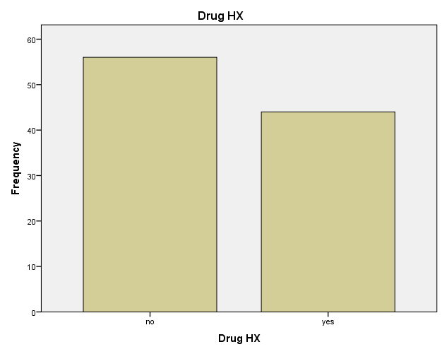

Discussion

- We reviewed 100 cases who have pre-eclampsia searching for the risk factors for developing it and we found the following percentage
- Age ,20 _less than 30 take 44%
- Multiparty take 47%
- History of contraceptive 57%
- History of misscareage 30%
- History of previous pre-eclampsia 41%
- Gestational HT 28%
- Chronic HT 23%, multiple gestation 13%
- H mole 6%
- History of abroptio placenta 14%

Conclusion
The rate of pre-eclampsia has been increased worldwide becaused of various risk facctors that affect maternal and fetal health in general
So the patient with pre-eclampsia should have frequent screening for her blood pressure, proteinuria,renal function test ,and monitoring the fetus for any distress or complications and should have frequent counseling To her doctoe for more advices because complications like eclampsia,heart failure, pulmonary odema, cerebral haemorrhage,renal failure and DIC can occure

References

- Ten Teachers,1917
- 2. World Health Organization. Appropriate technology for birth. Lancet. 1985;2(8452):436-7.
3. Hamilton BE, Martin JA, Ventura SJ. National Vital Statistics Reports. 2011;60,1. 4 . Belizan JM, Althabe F, Barros FC, Alexander S. Rates and implications of Cesarean Sections in Latin America: ecological study. BMJ. 1999;319:1397- 1402. 5. Hamilton BE, Ventura SJ, Martin JA, Sulton PD. Priliminary births for 2004: infant and maternal health. Health E-Stats. Released, 2005. 6. Stanton CK, Holtz SA. Studies in Family Planning, 2006. 7. Kambo I, Bedi N, Dhillon BS, Saxena AC. A critical appraisal of Cesarean section rates at teaching hospitals in India. Int J Gynaecol Obstet. 2002;79:151-8.

