ABNORMAL UTERINE BLEEDING

Definition: is a descriptive term applied to any alteration in normal pattern of menstrual flow
. excessive flow
. prolong flow
. intermenstrual bleeding
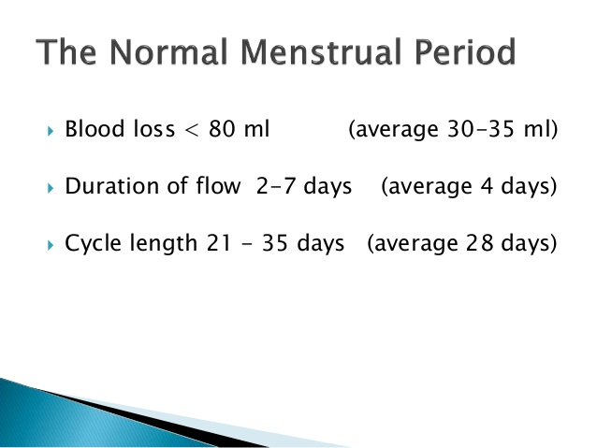 Classical nomenclature of abnormal uterine bleeding

Menorrhagia: prolonged and increased menstrual flow
Metrorrhagia: regular intermenstrual bleeding
Polymenorrhea: menses occurring at less than 21 days' interval
Hypermenorrhea: excessive regular menstrual bleeding
Menometrorrhagia: prolong menses and intermenstrual bleeding
Amenorrheore a absence of menstruation for more than 6 months
Oligomenorrhoea: menses at intervals of more than 35 days

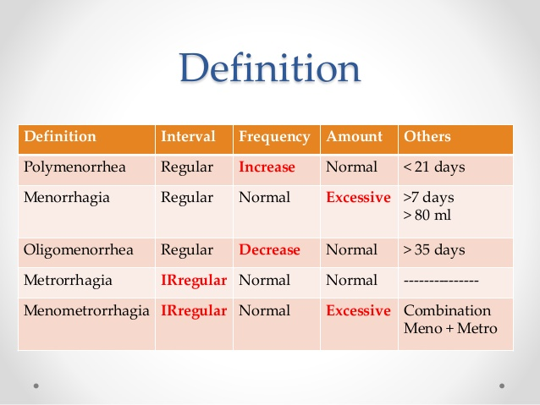
AETIOLOGY
1.organic causes
2. non organic causes this is called dysfunctional uterine bleeding (DUB)

ORGANIC CAUSES

General causes
. psychological or emotional can lead to abnormal bleeding through the effect on hypothalamus effecting hormonal control of the ovary or it act on autonomic nerves system supplying genital organ

. medication: exogenous steroid hormones neuroleptic. anticoagulant and cytotoxic drugs
. endocrine disorder: abnormal thyroid function, pituitary gland disorder, adrenal disorder, prolactin disorder, Diabetes mellitus
. Disorder of hemostasis
. liver and renal disease
.

B local causes
. pregnancy complication: implantation bleeding, all types of abortion, ectopic, trophoblastic disease
. congenital anomalies: double uterus increase surface area
Traumatic: local internal or external injuries, ring pessary
. IUCD
PID: either local endometritis or sever pelvic infection may effect ovarian function and secondarily abnormal menstruation
. hormonal producing tumor
. tumor of the uterus: benign fibroid common cause or malignant endometrial carcinoma
.end cervical polyp or hyperplasia
Cervical carcinoma
Rarities such as arteriovenous malformation in the uterus

NON ORGANIC CAUSES
. Known as dysfunction uterine bleeding
. any abnormal bleeding for which no organic cause can be detected

. responsible for 50% of abnormal bleeding
. diagnosis by exclusion
. classified to: ovulatory &anovulatary causes
An ovulatory cause
. this tend to occur in woman at the extremes of reproductive age and is typically irregular cycle .it is more common in obese women
Threshold bleeding: estrogen produce in amount enough to cause with drawl bleeding but not enough to produce proper proliferative endometrium (thin hypo plastic) this usually occur in adolescent and around menopause
Cystic glandular hyperplasia is the condition in which excessive and contiuos production of estrogen producing proliferative endometrium progress to hyperplasia so columnar epithelium become hypertrophy and stroma also proliferate with polymorph small haemorrgic area, necrosis and cystic dilation of the gland keeping the appearance of Suisse cheese appearance.

OVULATARY DUB
This pattern is more common in woman aged 35 – 45 and is typically regular heavy and often painful menstruation

Corpus luteum defect :
.corpus luteum slow to degenerate this cause prolong menstrual cycle and progesterone changes within the endometrium continue for longer time and there is premenstrual spoting
.corpus luteum slow to develop (corpus luteum insufficiency )menstrual loss is prolong may last 15 days

MANGEMENT
History and examination
.Patients will have different idea about heavy period so we have to confirm this is really heavy cycle
Soaked sanitary pad, presence of clots, blood spills over cloths or bedding, take any time off work due to this bleeding, treatment for anemia or blood transfusion
Type of abnormal bleeding whether continuous or regular or intermenstrual bleeding …………………
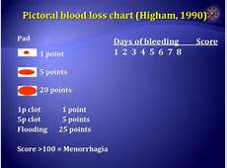
Examination:
Sign of anemia, sign of endocrine or medical disease that associated with heavy loss. abdominal and pelvic examination, cervix is visualized for polyp or carcinoma, cervical smear and swab
INVESTIGATIONS
. full blood count: assess severity and ascertain the need for treatment iron therapy or even blood transfusion
. coagulation screen: especially if history consistent with coagulation disorder
. pelvic ultrasound: mass fibroid, polyp, drug failure, endometrial thickness ,…………
. high vaginal and endocevical swab
. endometrial biopsy: should be performed
If age more than 45, irregular or intermenstrual bleeding, drug therapy has failed
Biopsy is performed either through outpatient Pipelle
Dilation and curettage
Outpatient hysteroscopy
Thyroid function test

Treatment
.for some woman ,the demonstration that their blood loss in fact normal may be sufficient to reassure them and make further treatment unnecessary
.when selecting appropriate management for the patient ,it is important to consider and discuss :.patients preference of treatment
.risk \benefit of each treatment
.contraceptive requirement complete family or not
.past medical history
.any contra indication to medical therapy
.suitability of anesthetic
MEDICAL TREATMENT:
Mefenamic acid and other NSAIDs
.reduce blood loss of 20 25 percent
.effective analgesia
.a number of contra indication like DU and asthma
Recommended dose 500 mg tds

Tranexamic acid
.reduction blood loss by 50 percent
.recommended dose 1 g qds to be taken when menstruating heavily

Combined oral contraceptive pills
.benefit double up as very effective contraceptive
.limited by side effect and contra indications ,age smoking ,obesity and family history

Norethisterone:
.cyclical from day 6 to day 26 of menstrual cycle
5 – 10 mg tds
Effective ,oral use but can cause break through bleeding
Levonogestrel intrauterine system (mirena )
.reduce menstrual blood by 95 %
.effective contraceptive
.disadvantages irregular menses and break through bleeding in the first 3 – 9 month after insertion
GnRH agonists
Act on pituitary to stop the production of estrogen which result in amenorrhea
.for short term use because its used limited due to hypo estrogenic state and can cause flushing and sweating
.use for maximum 6 month unless addback HRT
.effective in reducing dysmenorrhea
.can cause irregular bleeding
Dose Zoladex 3.6 mg monthly or Decapeptyl 3 mg monthly

SURGICAL TREATMENT
.failure of medical treatment
.complete family

Endometrial ablation
.destructive procedures employ the principle that ablation of endometrial lining of the uterus to sufficient depth prevents regeneration of the endometrium
.reduction blood loss by 95 %
.different method either resection of endometrium ,thermal ablation ,balloon thermal ablation ,microwave ablation

Hysterectomy

KEY POINT

. PREGNANCY SHOULD ALWAYS BE CONSIDERED AND EXCLUDED
. CONTRACEPTIVE HISTORY IS VITAL
. REGULAR BLEEDING USUALLY INDICATE HORMONAL OR SYSTEMIC CAUSE WHILE IIREGULAR BLEEDING INDICATE LOCAL CAUSE
. PATIENT AGE IMPORTANT AND MAY REFLECT THE UNDERLYING CAUSE
. EXTREME REPRODUCTIVE AGE USUALLY BENIGN AN OVULATORY DUB WHILE MIDDLE AGE USUALLY BENIGN ORGANIC PATHOLOGY AND IF DUB USUALLY OVULATORY TYPE
. COAGULATION DEFECT SHOULD BE EXCLUDED IN ANY ADOLECENT WITH ABNORMAL BLEEDING CAUSING SIGNIFICANT ANEMIA OR FAMILY HISTORY OF BLEEDING TENDANCY
. 