The Orbit

The anatomy of the orbit
The orbit is a pear-shaped cavity, the stalk of which is the optical canal through which the optic nerve pass from the orbit to the anterior cranial fossa.
1- The Roof: it is made of two bones; the lesser wing of sphenoid and the orbital plate of the frontal bone, located subjacent to the anterior cranial fossa and frontal sinus. A defect in the orbital roof (that occurs in some diseases like neurofibromatosis) may cause pulsatile proptosis due to transmission of CSF pulsation (that gets its pulsation from the pulsation of the intra cranial parts of internal carotid arteries).
2- The Lateral Wall: it is made of two bones; the greater wing of the sphenoid and zygomatic bone. It protects only the posterior half of globe, and the anterior half is uncovered, that is why the eyeball liable for trauma laterally.
3- The Floor: it is made of three bones; the zygomatic, maxillary (both form the anterior 2/3) and palatine (forms posterior 1/3) bones. The posteromedial portion of maxillary bone is weak liable for fracture and may be involved in a blowout fracture.
4- The Medial Wall: It is made of four bones; the maxillary (frontal process), lacrimal, ethmoid and the body of sphenoid. Lamina papyracea covers the medial wall is a paper-thin and perforated by foramina for nerves and blood vessels. Orbital cellulitis is therefore commonly occurs secondary to ethmoidal sinusitis.
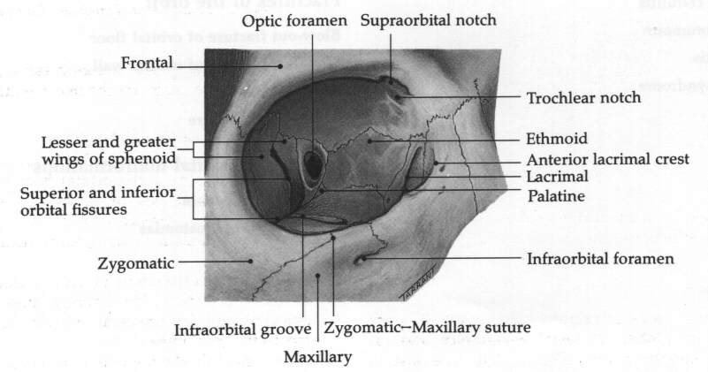

Clinical signs of orbital disease

1- Soft tissue involvement:
a- Signs:
i- Lid and periorbital oedema.
ii- Ptosis: Mechanical ptosis due to swelling of lid.
iii- Conjunctival chemosis (oedema) and conjunctival injection.
b- Causes:
i- Thyroid eye disease.
ii- Orbital cellulitis.
iii- Inflammatory orbital disease.
iv- Arterio-venous shunts.

2- Proptosis:
Abnormal forward displacement of the globe caused by retro-bulbar lesion or less frequently by shallow orbit which is usually congenital. Diagnosis of proptosis by inspection from above and behind is difficult especially if it is bilateral.
a- The direction of proptosis: it is either axial or eccentric (upwards, downwards, medial or lateral). An intraconal mass, e.g. cavernous haemangioma and optic nerve glioma, will push the eyeball axially. However, an extraconal mass will cause eccentric proptosis.'
b- The severity of proptosis: is usually evaluated either by simple plastic ruler (placed at the lateral margin to measure the position of the apex of cornea), or by Hertel exophthalmometer (a plate attached to it 2 mirrors placed at 45°). Normally, the apex of the cornea is up to 20 mm anterior to lateral orbital margin, and anything more than 21 mm is considered proptosis, which is divided according to severity into:
- Mild: 21-23mm.
- Moderate: 24-27mm.
- Severe: >28mm.

proptosis diagnosed by inspection.
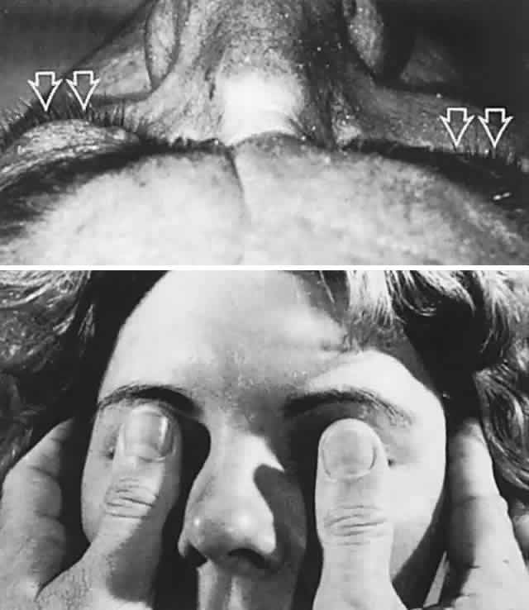

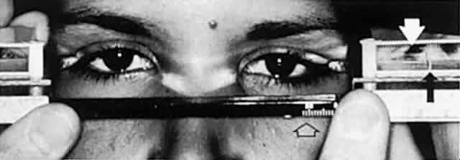

Exophthalmometry with Hertel instrument. White arrow indicates cornea of left eye as viewed through right-angle prism. Black arrow indicates mires fixed at 18 mm. Open arrow indicates baseline gauge. Note position of footplates placed against lateral orbital rims.
c- Exclude pseudo-proptosis: As in ipsilateral lid retraction, contralateral enophthlamos, enlargement of eyeball in unilateral high myopia and buphthalmos.

3- Enophthalmos:
The globe is recessed within the orbit. Causes:
a- Small globe, congenital anomaly, e.g. microphthalmos or nanophthalmos.
b- Structural bony abnormalities, blowout fracture of floor or lamina papyracea that causes herniation of orbital fatty tissue causing enophthalmos, congenital bone defects is another cause for enophthalmos.
c- Atrophy of orbital contents, after radiotherapy in malignant tumors of the orbit or trauma.
d- Cicatrizing orbital lesions, such as chronic sclerosing inflammatory orbital disease, secondary malignancy or carcinoma of orbit causing fibrosis of intraorbital structure and traction of eyeball.

4- Ophthalmoplegia:
defective ocular motility, caused by:
a- Orbital mass: Due to large intraorbital mass, there will be restriction of movement to one side or another.
b- Restrictive myopathy in thyroid diseases.
c- Ocular motor nerves lesions: damage to 3rd, 4th or 6th cranial nerves.
d- Tethering of extraocular muscles or fascia in a blowout fracture: herniation of muscles or tethering (entrapment) of these muscles in the fracture.
e- Splinting of optic nerve by optic nerve sheath meningioma.

5- Visual dysfunction (reduced visual acuity):
a- Exposure keratopathy.
b- Compressive optic neuropathy.
c- Choroidal folds at macula.

6- Dynamic properties:
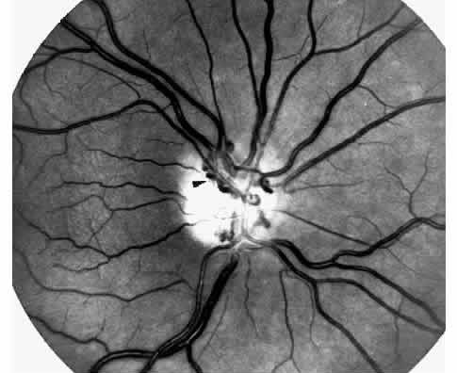
a- Increasing venous pressure: by dependant head posture, valsalva maneuver, jugular compression, during the crying of the child, there is enlargement of the size of the mass. This is seen in venous anomalies, cavernous and capillary haemangiomas.
b- Pulsation: It is caused by either A-V communication or herniation of meninges with CSF from the anterior cranial fossa through a defect in the orbital roof.
c- Bruit: it is a sign of carotid-cavernous fistula.

7- Fundus changes:
a- Optic disc atrophy. Caused by inflammation or compressing on the optic nerve.
b- Optociliary shunt; Optociliary veins can be seen only when there is central retinal vein occlusion; so these vessels shunting the blood from the retina to the choroidal venous circulation. Common tumors associated with this shunt are optic nerve sheath meningioma and glioma.
c- Choroidal folds (tumors, Thyroid ophthalmopathy).
d- Retinal vascular changes (venous dilatation, tortuosity, swollen disc and vascular occlusions).

8- Dystopia:
Displacement of the eyeball across the coronal plane of orbit, as in case of tumor of lacrimal gland, that is situated between the roof and the lateral wall, which will lead to displacement of the eyeball downwards and medially. The degree of displacement can be measured by a ruler whether horizontal or vertical.

Investigation:
CT, MRI (contraindicated in case of metallic foreign bodies), Plain X-Ray, and fine needle biopsy (FNB) under guidance of CT especially in orbital metastasis.

Orbital infection
1- Preseptal cellulitis:
It is relatively common infection of subcutaneous tissue anterior to the orbital septum.
Causes:
a- Skin trauma, lacerations or insect bites. Organism is usually staphylococcus aureus or streptococcus pyogenes.
b- Spread of local infection; such as dacryocystitis and acute hordeolum (internal or external).
c- From remote infection: of the upper respiratory tract infection or middle ear infection by hematogenous spread.
Signs:
Unilateral, tender, red periorbital and lid swelling, proptosis is absent, visual acuity and pupillary reaction and ocular motility are normal (to differentiate it from orbital cellulitis).
Treatment:
Oral co-amoxiclav 250mg is given every 6 hours. Severe infections are requiring IM benzylpenicillin 2.4 - 4.8mg in four divided doses and oral flucloxacillin 250-500mg every 6 hours in addition to topical antibiotic in forms of drop and ointment. (e.g. Gentamycin or chloramphinicol)

2- Bacterial orbital cellulitis:
An infection of the soft tissues behind the orbital septum, it is a polymicrobial infection including anaerobes, streptococcus pneumoniae, staphylococcus aureus and streptococcus pyogenes, and in children under 5 years, haemophilus influenzae may be included.
Causes:
a- Sinus-related: The most common one is ethmoidal sinusitis (as there is only the thin plate in between "lamina papyracea".
b- Extension of preseptal cellulitis.
c- Spread from adjacent dacryocystitis, mid-facial and dental infection.
d- Post-traumatic: Develops within 72 hours of injury that penetrates the orbital septum.
e- Post-surgical: May complicates retinal, lacrimal or orbital surgery.
f- Haematogenous spread.
Clinical features:
Occur at any age but more common in children (as they are more prone to develop upper respiratory tract infection), patient usually presented with severe malaise, fever, pain and visual impairment.
Signs:
a- Swollen, tender, red and warm lids (unilateral).
b- Proptosis.
c- Painful ophthalmoplegia (may cause diplopia).
d- Signs of optic nerve dysfunction (seen in advanced cases).
Complications:
a- Ocular: Exposure keratopathy (due to proptosis), increased intraocular pressure (due to pressure from outside), central retinal vein occlusion CRVO, central retinal artery occlusion CRAO (also due to external pressure).
and optic neuritis (infection).
b- Intracranial: They are rare like; meningitis, brain abscess and cavernous sinus thrombosis.
c- Orbital abscess.
Management:
a- Hospitalization: It is mandatory as the infection is life threatening.
b- Antibiotics: - IV Ceftazidine 1g x 3.
- IV Metronidazol 500mg x 3.
- IV Penicillin (or vancomycin).
* We must use triple antibiotics (for anaerobes, G+ve and G-ve)
c- Optic nerve function: should be monitored every four hours:
i- Light pupillary reaction.
ii- Visual acuity.
iii- Color vision.
iv- Light brightness appreciation.
d- Investigations:
i- WBC count.
ii- Blood culture (to exclude haematogenous spread and septicaemia).
iii- CT of the orbit, sinuses and brain. It is used to differentiate preseptal from orbital cellulitis.
iv- Lumbar puncture: if meningeal or cerebral signs develop.
e- Surgical intervention: should be considered in:
i- Unresponsiveness to antibiotics.
ii- ↓ visual acuity.
iii- Orbital abscess.
iv- Atypical picture, which may merit diagnostic biopsy.
* Surgery is done to drain abscess or decompress the walls of orbit to decrease pressure on optic nerve.

3- Rhino-orbital mucormycosis:
It is an opportunistic infection caused by fungi of the family mucoraceae, which typically affects patients with diabetic ketoacidosis or imunosuppression.
This aggressive and fatal infection is acquired by the inhalation of spores, which give rise to upper respiratory tract infection. The infection then spreads to the sinuses, orbit and brain.
Invasion of blood vessels by the hyphae results in occlusive vasculitis with ischaemic infarction of orbital tissues.
Presentation:
Gradual onset facial and periorbital swelling, diplopia (due to ophthalmoplegia) and visual loss.
Signs:
- Ischaemic infarction superimposed on septic necrosis is responsible for the black eschar which may develop on the hard palate, turbinates, nasal septum, skin and eyelids
- Ophthalmoplegia.
- Progression is slower than in orbital cellulitis.
Treatment:
a- IV amphotericin.
b- Daily irrigation of involved area with amphotericin.
c- Wide excision of necrotic tissue.
d- Hyperbaric O2.
e- Exenteration (in severe unresponsive cases).

Orbital inflammatory diseases
1- Idiopathic orbital inflammatory disease IOID (Orbital pseudotumor):
Non-neoplastic, non-infectious, space occupying orbital lesions, inflammatory process may involve any or all soft tissue components of the orbit. In adults, unilateral involvement is the rule, while in children; there is bilateral involvement in 30% of cases.
Clinical features:
Presentation is usually at 20-50 years old with abrupt painful onset, usually unilateral.
Signs:
a- Periorbital swelling, chemosis and conjunctival inflammation.
b- Proptosis.
c- Painful ophthalmoplegia.
d- Due to pressure effect, Optic nerve dysfunction (impaired visual acuity, color vision, visual field, diminished light brightness appreciation).
Clinical course:
- Spontaneous remission after a few weeks.
- Prolonged intermittent episodes of activity with eventual remission (on/off).
- Severe prolonged inflammation leading to fibrosis of orbital tissues "Frozen orbit".
Management:
- Systemic steroids: effective in 50-75%, we use oral 60-80mg Prednisolone.
- Radiotherapy: if there is no response to systemic steroids.
- Cytotoxic drugs: cyclophosphamide 200 mg/day.
- Biopsy may be needed in persistent cases (to exclude other differential diagnoses).

Differential diagnosis:
a- Bacterial orbital cellulitis.
b- Severe acute thyroid eye disease (TED).
c- Systemic disorders (Wegener's granulomatosis, polyarteritis nodosa).
d- Malignant orbital tumors.
e- Rupture dermoid cyst.

2- Acute dacryoadenitis:
Is inflammatory process involving the lacrimal gland, which occurs in about 25% of IOID. More commonly, it occurs in isolation.
It usually resolves spontaneously and does not require treatment.
Presentation:
Is acute discomfort in the region of the lacrimal gland (upper lateral part of orbit).
Signs:
- Swelling of lacrimal aspect of the eyelid causing ptosis (mechanical ptosis).
- Mild downward and inward dystopia.
- Tenderness over the gland.
- Injection of the palpebral portion of the lacrimal gland and adjacent conjunctiva.
- Decreased lacrimal secretion.
Differential diagnosis:
a- Infection of the lacrimal gland.
b- Ruptured dermoid cyst.
c- Malignant tumors of the lacrimal gland.

Thyroid eye diseases
Thyrotoxicosis (Graves' disease):
- It is an autoimmune disorder.
- Usually presents in the 3rd-4th decades of life.
- Affects women more than men.
- It is the most common cause of unilateral and bilateral proptosis.
The occurrence of signs of Graves' disease in a patient who is not clinically hyperthyroid is referred to as euthyroid or ophthalmic Graves' disease.
Pathogenesis:
1- Inflammation of extraocular muscles (pleomorphic cellular infiltration, increase secretion of glycosaminoglycans and osmotic imbibitions of water) causes muscles enlargement up to 8 times and may compress the optic nerve. Subsequently, muscles degeneration occurs and eventually leads to fibrosis which exerts a tethering effect on the involved muscle, resulting in restrictive myopathy and diplopia.
2- Inflammatory cellular infiltration with Lymphocytes, plasma cells, macrophages and mast cells of interstitial tissues, orbital fat and lacrimal glands associated with accumulation of glycosaminoglycans and retention of fluid. This causes increase in the volume of orbital contents and secondary elevations of intraorbital pressure, which may itself cause further fluid retention within the orbit.

Clinical manifestations:
There are two stages in the development of the disease:
1- Congestive (inflammatory or acute) stage:
The eyes are red and painful. This stage leads to remit within 3 years.
2- Fibrotic (quiescent) stage:
The eyes are white, painless and motility defects are present.
There are mainly five clinical manifestations: 1- Soft tissue involvement.
2- Lid retraction. 3- Proptosis. 4- Optic neuropathy. 5- Restrictive myopathy.

1- Soft tissue involvement:
Symptoms:
Grittiness, photophobia, lacrimation and retrobulbar discomfort.
Signs:
- Periorbital and lid swelling.
- Conjunctival and episcleral hyperaemia.
- Chemosis.
- Keratoconjunctival sicca (due to lacrimal gland involvement).
- Superior limbic keratoconjunctivitis.

Management:
a- Topical lubricant: e.g. artificial eye drops, for superior limbic keratoconjunctivitis, corneal exposure (proptosis) and dryness.
b- Head elevation: to decrease periorbital oedema.
c- Taping of the eyelids: during sleep to prevent exposure keratopathy.

2- Lid retraction:
Retraction of upper and lower lids occurs in about 50% of patients with Graves' disease. (It is something differs from lid lags. What is lid lags?)
Pathogenesis of lid retraction:
a- Fibrotic contracture of the levator palpebrae superioris (for upper lid) and inferior rectus (for lower lid) is one cause for lid retraction. Usually the upper lid covers 2mm below the superior limbus and the lower lid lies at the lower limbic margin, when the lids are away from these sites and there is appearance of sclera between lid margin and limbus called lid retraction.
b- Overaction of levator-superior rectus complex due to fibrosis and tethering of the inferior rectus muscle. The first (& most common) muscle involved is the inferior rectus, so the superior rectus try to compensate for overactivity of inferior rectus, but as there is a complex between super rectus and levator palpebrae superioris (both lies in a common sheath), this will cause contraction of the levator muscle and elevation of the upper lid.
c- Overaction of Muller muscle due to sympathetic overstimulation secondary to high level of thyroid hormones.
Signs:
- The upper lid margin is either at level with or above the superior limbus (allowing the sclera to be visible).
Treatment:
Mild cases usually resolve spontaneously specially if there is good control of hyperthyroidism.
Surgical correction is indicated only with significant and stable retraction.

3- Proptosis:
It is axial (as all muscles, intraorbital tissues and fat are involved), unilateral or bilateral, symmetrical or asymmetrical and frequently permanent.
Management:
a- Systemic steroids: in rapidly progressive and painful proptosis.
- Initially; we start with 60-80 mg oral Prednisolone.
- IV methyl Prednisolone (o.5 gm in 200 ml saline over 30 min) which may be repeated after 48 hours. It is indicated if there is compressive optic neuropathy (at the annulus of Zinn, muscular enlargement leads to compression of optic nerve).
b- Radiotherapy: when steroids are contraindicated or when there is compressive optic neuropathy or to prevent it.
c- Combined therapy (Irradiation, azathioprine and low dose of steroids), it is more effective than steroids or radiotherapy alone.
d- Surgical decompression: either as primary treatment or when non-invasive methods are ineffective. It is two-wall (inferior and medial walls), three-wall (inferior, medial and lateral walls) or four-wall (inferior, medial, lateral and lateral part of the roof).

4- Optic neuropathy:
It is a serious complication affecting about 5% of patients. It is caused by compression of the nerve or its blood supply by congested and enlarged recti muscles. It may lead to severe and permanent but preventable visual acuity impairment.
Presentation:
a- Decreased visual acuity.
b- Impaired color vision, e.g. TV screen.
Signs:
- RAPD (Relative Afferent Pupillary Defect)
- Abnormal visual parameters: e.g. Decreased visual acuity, Color desaturation (lighter colors), Diminished light brightness appreciation, and Visual field defect, like central and paracentral defects.
- Increased intraocular pressure.
- Optic disc: it is normal, but occasionally swollen and rarely atrophic.
Treatment:
a- IV methyl Prednisolone (it is a serious condition).
b- Orbital decompression if (a) not effective.

5- Restrictive myopathy:
Between 30-50% of patients with TED develop ophthalmoplegia which may be permanent.
Signs:
- Restriction of ocular motility, initially by inflammatory oedema and later by fibrosis.
- Increased intraocular pressure in up-gaze due to ocular compression a fibrotic inferior rectus.

In order of frequency:
a- Elevation defect by inferior rectus involvement.
b- Abduction defect by medial rectus involvement.
c- Depression defect by superior rectus involvement.
d- Adduction defect by lateral rectus involvement.

Treatment:
a- Surgery:
Indication: Diplopia in primary or reading positions.
Goal: to achieve binocular single vision in primary and reading positions.
Technique: Recession of restricted muscle.
b- Botulinum toxin injection:
Into the involved muscle may be useful in selected cases (it is of temporary effect).

General information's out of this lecture:

In ophthalmology we should differentiate between those 3 terms:

* Exenteration: Complete excision of the lids, conjunctiva, eyeball and all other intraorbital structures (extraorbital muscles and orbital fat). In modified type exenteration, the lids are splitting through the gray line in to 2 lamellae, anterior and posterior, the posterior lamellae is excised only in addition to conjunctiva, eyeball and other intra orbital structures. (anterior lamellae of lids left for cosmetic reason)
* Evisceration: is excision of the cornea and take it out, then evacuation of all intraocular contents. (We are leaving empty sclera only)
* Enucleation: excision of the eyeball as a whole

