بسم الله الرحمن الرحيم
﴿ وقل ربِ زدني علما﴾

Etiological factor s that increase the incidence of cesarean section in Bint AL huda hospital at 2018-2019
- Done by
Khyriah Shahad
- Rania shawqi
Supervised by
Wassan Raheem Mubark Dr.
Dr.Muslium N. Saeed

Abstract
Visiting to wards of Bint AL huda hospital two time per day to collect the appropriate information from the patients who are admitted to the wards searching about the etiological factors that increase the incidence of cesarean section

Introduction

Caesarean section
Defi nition
A Caesarean section, also known as C-section or Caesar, is a surgical procedure in which incisions are made through a mother’s abdomen (laparotomy) anduterus (hysterotomy) to deliver one or more babies.
There are three theories about the origin of thename. The name is said to derive from a Roman legalcode called Lex Caesarea, which allegedly contained alaw prescribing that the baby be cut out of its mother’s womb in the case that she dies before giving birth. The derivation of the name is also often attributed to anancient story, told in the first century AD by Pliny the
Elder, who claimed that an ancestor of Caesar was
delivered in this manner. An alternative etymology suggests that the procedure’s name derives from the Latin verb caedere, to cut, in which case the term ‘Caesarean section’ is redundant. Caesar’s mother, Aurelia, lived through childbirth and successfully gave birth to her son, ruling out the
possibility that the Roman dictator and general was born by Caesarean section. However, the Catalan
saint, Raymond Nonnatus (1204–40), received his surname (from the Latin non natus, not born) because he was born by Caesarean section; his mother died while giving birth to him. In 1316, the future Robert II of Scotland was delivered by Caesarean section and his mother, Marjorie Bruce, died (this may have been the inspiration for Macduff in Shakespeare’s play Macbeth). The first recorded incidence of a woman surviving a Caesarean section was in 1500, in Siegershausen, Switzerland: Jakob Nufer, a pig gelder, is supposed to have performed the operation on his wife after a prolonged labour. For most of the time since the sixteenth century, the procedure had a
high mortality. A Caesarean section was considered an extreme measure, performed only when the mother was already dead or considered to be beyond help. In Great Britain and Ireland, the mortality rate in 1865 was 85 per cent. Key steps in reducing mortality were:
• adherence to principles of asepsis;
• the introduction of uterine suturing by Max Sänger in 1882;
• extraperitoneal Caesarean section and then moving to low transverse incision;
• anaesthesia advances;
• blood transfusion;
• antibiotics
On March 5, 2000, Inés Ramírez performed a Caesarean section on herself and survived, as did her son. She is believed to be the only woman to have performed a successful Caesarean section on herself. Birth by Caesarean section has become a commonplace intervention on the modern labour ward. According to some, the Caesarean section rate has reached epidemic proportions and requires a dramatic rethink of obstetric management.
Prevalence
In the UK, more than 21 per cent of all babies are now delivered by Caesarean section. The principal aims must be to ensure that those women and babies who need delivery by Caesarean section are so delivered and that those who do not are saved from unnecessary intervention. In 1985, concern regarding the increasing frequency of Caesarean section led the World Health Organization to hold a consensus.

conference. This conference concluded that there were no health benefits above a Caesarean section rate of 10–15 per cent. The Scandinavian countries have managed to hold Caesarean section rates at this level with outcomes comparable or better than those countries with higher Caesarean section rates.
There are various factors involved in the rise of rate of cesarean section. There has been an increase in primary cesarean section rate, a decrease in vaginal birth after CS trial, decrease in operative vaginal deliveries (Forceps/Ventouse),
increase in litigations, increasing facility of electronic monitoring, and decreasing threshold of patients for bearing labor pains .The commonest cause for CS in worldwide is previous scar.

METHODIES
We conducted retrospective analytical study of various indications of cesarean section in 100 patients who underwent cesarean delivery at 2018- 2019 . We took detailed history, including name, age,parity, obstetric
history, indications and date of cesarean sections, to those mothers. We analysed the data so as to study the factors responsible for high rate of cesarean section. Data of all the 100 patients were analysed by using SPSS version 2007 Software and Microsoft excel

Frequencies
Frequency Table

Age
 |  | Frequency | Percent | Valid Percent | Cumulative Percent
Valid | 15-19 years | 1 | 1.0 | 1.0 | 1.0
 | 20-29 years | 45 | 45.0 | 45.0 | 46.0
 | 30 and above | 54 | 54.0 | 54.0 | 100.0
 | Total | 100 | 100.0 | 100.0

Parity
 |  | Frequency | Percent | Valid Percent | Cumulative Percent
Valid | para 1 | 21 | 21.0 | 21.0 | 21.0
 | para 2-4 | 65 | 65.0 | 65.0 | 86.0
 | para 5 and more | 14 | 14.0 | 14.0 | 100.0
 | Total | 100 | 100.0 | 100.0

 |  | Frequency | Percent | Valid Percent | Cumulative Percent
Valid | poor | 37 | 37.0 | 37.0 | 37.0
 | good | 63 | 63.0 | 63.0 | 100.0
 | Total | 100 | 100.0 | 100.0
ANC
previous scar
 |  | Frequency | Percent | Valid Percent | Cumulative Percent
Valid | no | 59 | 59.0 | 59.6 | 59.6
 | yes | 40 | 40.0 | 40.4 | 100.0
 | Total | 99 | 99.0 | 100.0
Missing | System | 1 | 1.0
Total |  | 100 | 100.0

HT
 |  | Frequency | Percent | Valid Percent | Cumulative Percent
Valid | no | 93 | 93.0 | 93.0 | 93.0
 | yes | 7 | 7.0 | 7.0 | 100.0
 | Total | 100 | 100.0 | 100.0

DM
 |  | Frequency | Percent | Valid Percent | Cumulative Percent
Valid | no | 100 | 100.0 | 100.0 | 100.0

Macrosomia
 |  | Frequency | Percent | Valid Percent | Cumulative Percent
Valid | no | 100 | 100.0 | 100.0 | 100.0

SGA
 |  | Frequency | Percent | Valid Percent | Cumulative Percent
Valid | no | 100 | 100.0 | 100.0 | 100.0

Congenital anomilies
 |  | Frequency | Percent | Valid Percent | Cumulative Percent
Valid | no | 98 | 98.0 | 98.0 | 98.0
 | yes | 2 | 2.0 | 2.0 | 100.0
 | Total | 100 | 100.0 | 100.0

Bleeding
 |  | Frequency | Percent | Valid Percent | Cumulative Percent
Valid | no | 96 | 96.0 | 96.0 | 96.0
 | yes | 4 | 4.0 | 4.0 | 100.0
 | Total | 100 | 100.0 | 100.0

placenta previa
 |  | Frequency | Percent | Valid Percent | Cumulative Percent
Valid | no | 99 | 99.0 | 99.0 | 99.0
 | yes | 1 | 1.0 | 1.0 | 100.0
 | Total | 100 | 100.0 | 100.0

CPD
 |  | Frequency | Percent | Valid Percent | Cumulative Percent
Valid | no | 93 | 93.0 | 93.9 | 93.9
 | yes | 6 | 6.0 | 6.1 | 100.0
 | Total | 99 | 99.0 | 100.0
Missing | System | 1 | 1.0
Total |  | 100 | 100.0

Oligohydrominous
 |  | Frequency | Percent | Valid Percent | Cumulative Percent
Valid | no | 99 | 99.0 | 99.0 | 99.0
 | yes | 1 | 1.0 | 1.0 | 100.0
 | Total | 100 | 100.0 | 100.0

Bar Chart

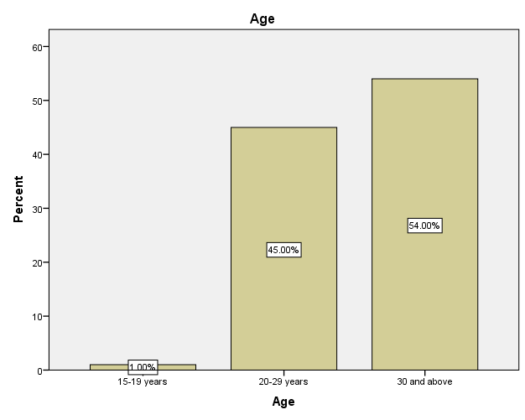

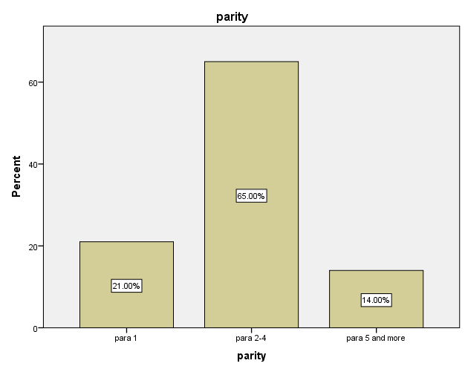

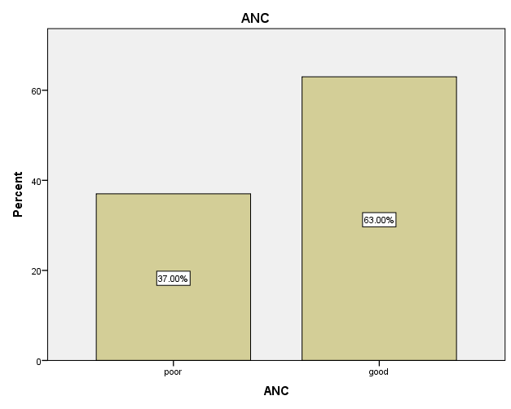

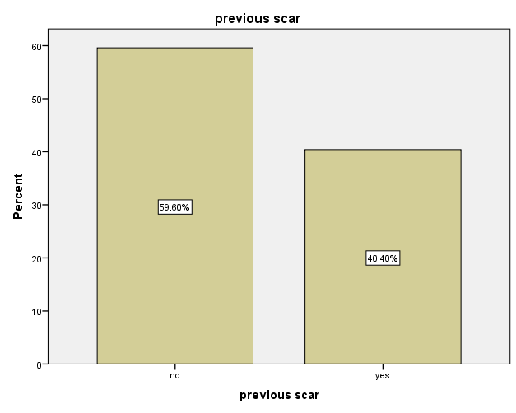

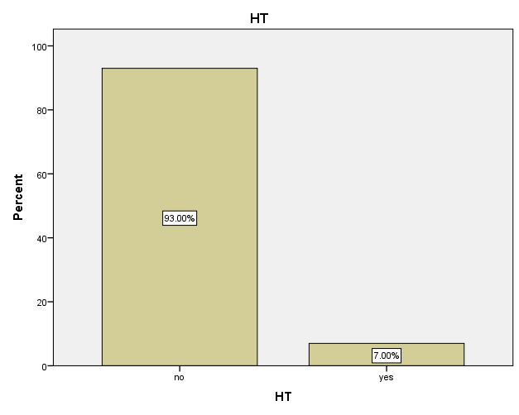
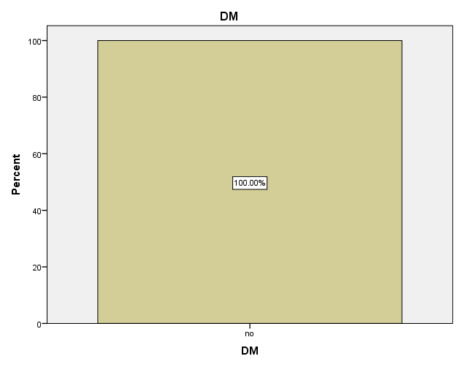

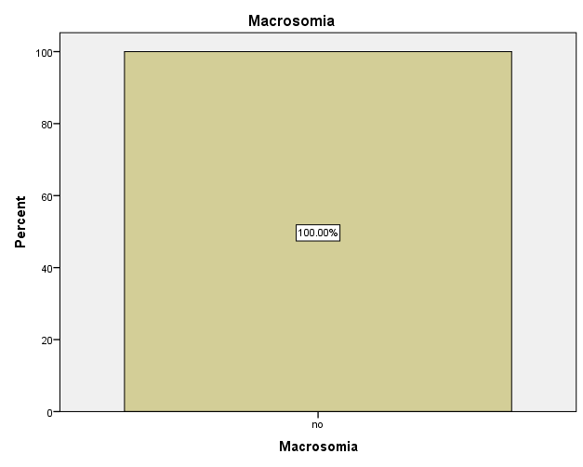

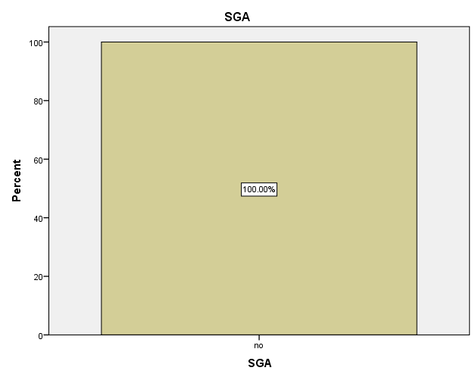

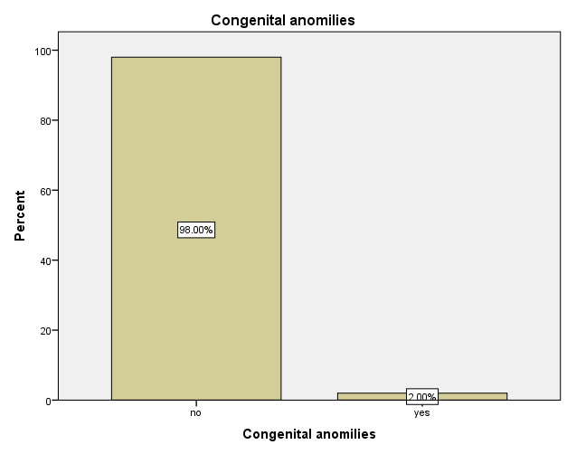

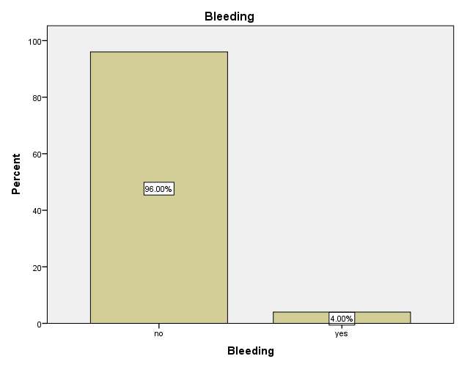

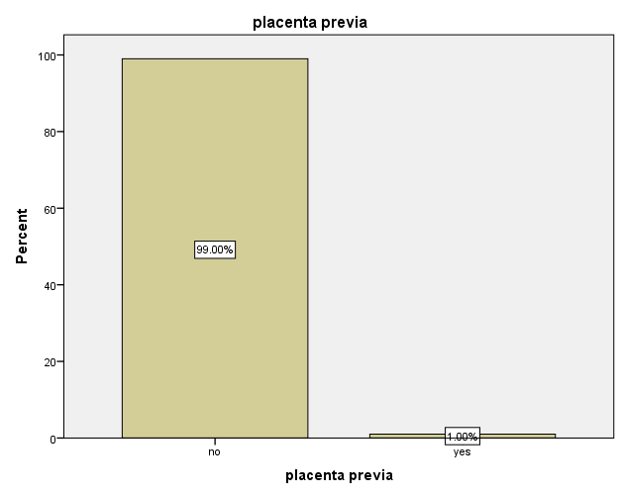

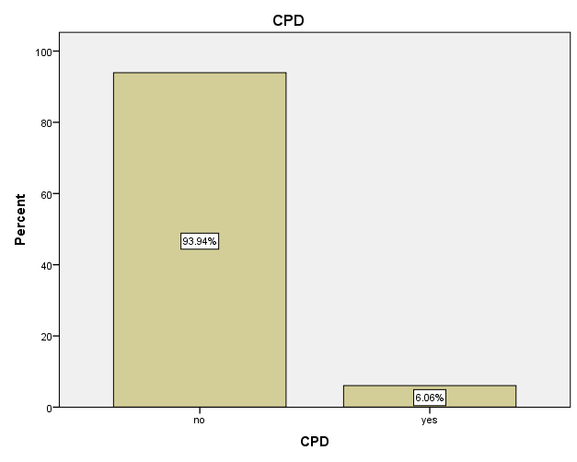

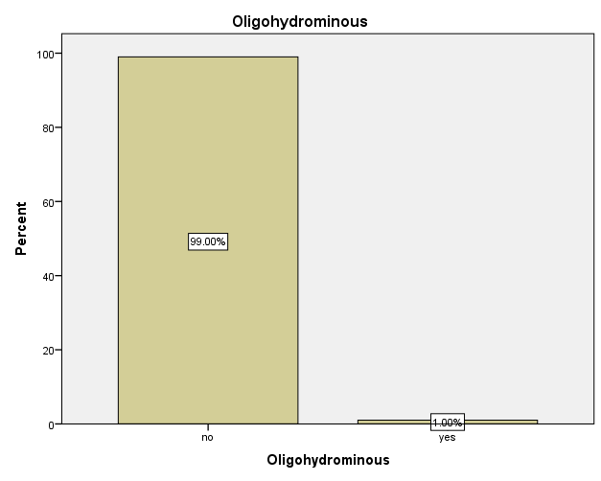

FREQUENCIES VARIABLES=Oldprimi postdate multiplepregnancy preciousbaby priortraumaticbirth
Failuretoprogress Patientrequest Doctorrecommendation badobstetricHX Abnormalpresentation
Pretermlabor Fetaldistress
/PIECHART PERCENT
/ORDER=ANALYSIS.

Frequencies
Notes
Output Created |  | 09-APR-2019 22:17:09
Comments
Input | Active Dataset | DataSet1
 | Filter | <none>
 | Weight | <none>
 | Split File | <none>
 | N of Rows in Working Data File | 100
Missing Value Handling | Definition of Missing | User-defined missing values are treated as missing.
 | Cases Used | Statistics are based on all cases with valid data.
Syntax |  | FREQUENCIES VARIABLES=Oldprimi postdate multiplepregnancy preciousbaby priortraumaticbirth  Failuretoprogress Patientrequest Doctorrecommendation badobstetricHX Abnormalpresentation  Pretermlabor Fetaldistress  /PIECHART PERCENT  /ORDER=ANALYSIS.
Resources | Processor Time | 00:00:02.17
 | Elapsed Time | 00:00:01.84

Statistics
 |  | Old primi | post date | multiple pregnancy | precious baby | prior traumatic birth
N | Valid | 100 | 100 | 100 | 100 | 100
 | Missing | 0 | 0 | 0 | 0 | 0
Statistics
 |  | Failure to progress | Patient request | Doctor recommendation | bad obstetric HX | Abnormal presentation
N | Valid | 100 | 100 | 100 | 100 | 100
 | Missing | 0 | 0 | 0 | 0 | 0

Statistics
 |  | Preterm labor | Fetal distress
N | Valid | 100 | 100
 | Missing | 0 | 0

Frequency Table

Old primi
 |  | Frequency | Percent | Valid Percent | Cumulative Percent
Valid | no | 99 | 99.0 | 99.0 | 99.0
 | yes | 1 | 1.0 | 1.0 | 100.0
 | Total | 100 | 100.0 | 100.0

post date
 |  | Frequency | Percent | Valid Percent | Cumulative Percent
Valid | no | 95 | 95.0 | 95.0 | 95.0
 | yes | 5 | 5.0 | 5.0 | 100.0
 | Total | 100 | 100.0 | 100.0

multiple pregnancy
 |  | Frequency | Percent | Valid Percent | Cumulative Percent
Valid | no | 97 | 97.0 | 97.0 | 97.0
 | yes | 3 | 3.0 | 3.0 | 100.0
 | Total | 100 | 100.0 | 100.0

precious baby
 |  | Frequency | Percent | Valid Percent | Cumulative Percent
Valid | no | 98 | 98.0 | 98.0 | 98.0
 | yes | 2 | 2.0 | 2.0 | 100.0
 | Total | 100 | 100.0 | 100.0

prior traumatic birth
 |  | Frequency | Percent | Valid Percent | Cumulative Percent
Valid | no | 100 | 100.0 | 100.0 | 100.0

Failure to progress
 |  | Frequency | Percent | Valid Percent | Cumulative Percent
Valid | no | 92 | 92.0 | 92.0 | 92.0
 | yes | 8 | 8.0 | 8.0 | 100.0
 | Total | 100 | 100.0 | 100.0

Patient request
 |  | Frequency | Percent | Valid Percent | Cumulative Percent
Valid | no | 100 | 100.0 | 100.0 | 100.0

Doctor recommendation
 |  | Frequency | Percent | Valid Percent | Cumulative Percent
Valid | no | 100 | 100.0 | 100.0 | 100.0

bad obstetric HX
 |  | Frequency | Percent | Valid Percent | Cumulative Percent
Valid | normal obstetric history | 79 | 79.0 | 79.0 | 79.0
 | bad obstetric history | 21 | 21.0 | 21.0 | 100.0
 | Total | 100 | 100.0 | 100.0

Abnormal presentation
 |  | Frequency | Percent | Valid Percent | Cumulative Percent
Valid | normal presentation | 90 | 90.0 | 90.0 | 90.0
 | abnormal presentation | 10 | 10.0 | 10.0 | 100.0
 | Total | 100 | 100.0 | 100.0

Preterm labor
 |  | Frequency | Percent | Valid Percent | Cumulative Percent
Valid | no | 99 | 99.0 | 99.0 | 99.0
 | yes | 1 | 1.0 | 1.0 | 100.0
 | Total | 100 | 100.0 | 100.0

Fetal distress
 |  | Frequency | Percent | Valid Percent | Cumulative Percent
Valid | no | 93 | 93.0 | 93.0 | 93.0
 | yes | 7 | 7.0 | 7.0 | 100.0
 | Total | 100 | 100.0 | 100.0

Pie Chart

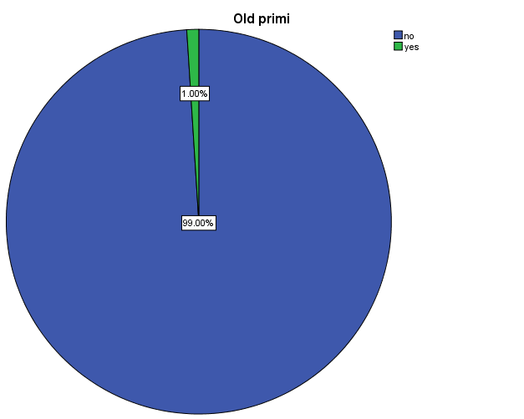

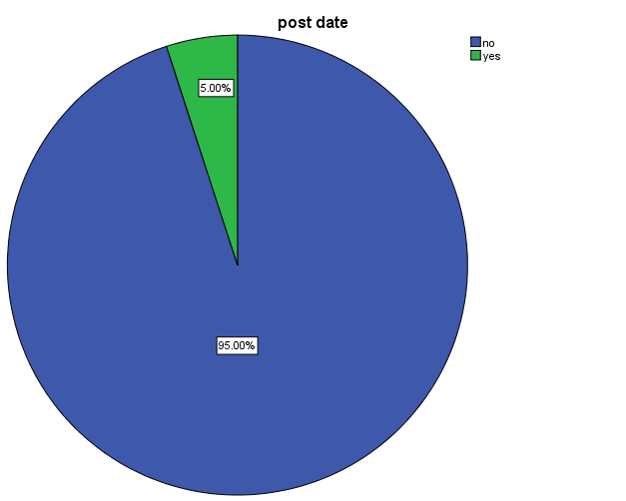

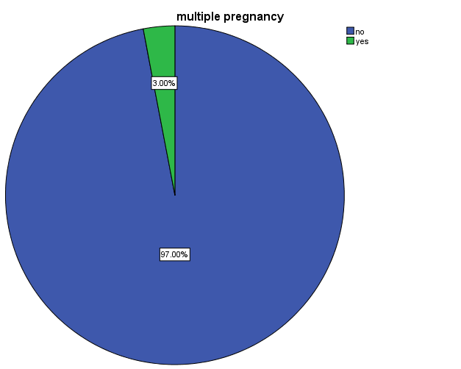

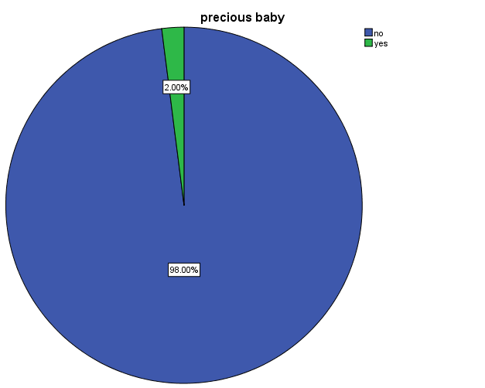

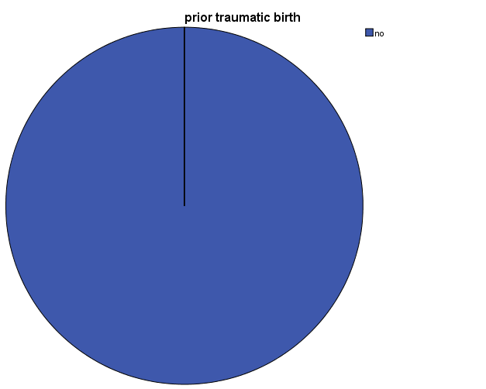

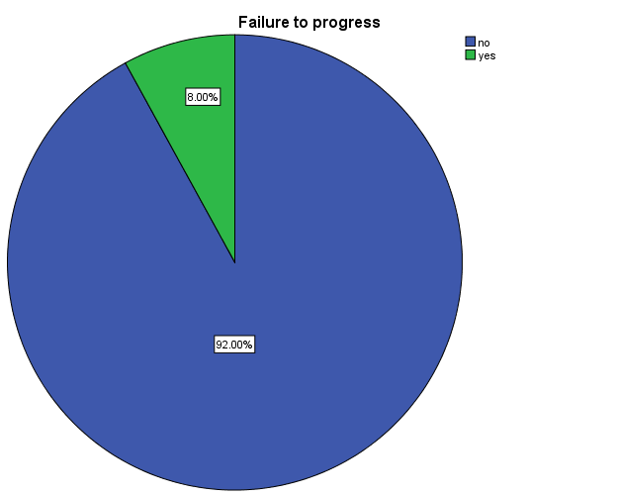

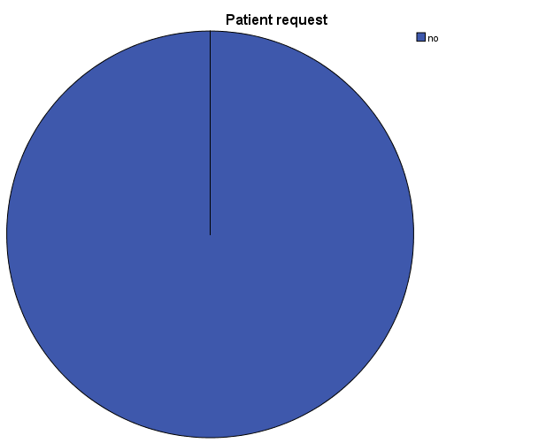

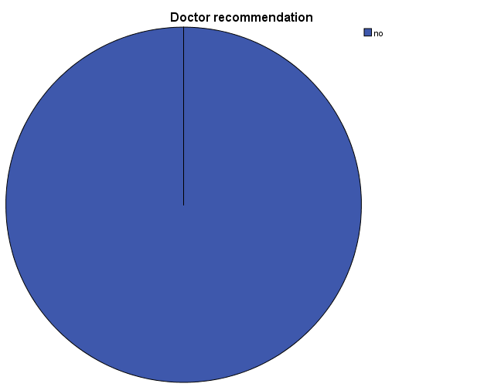

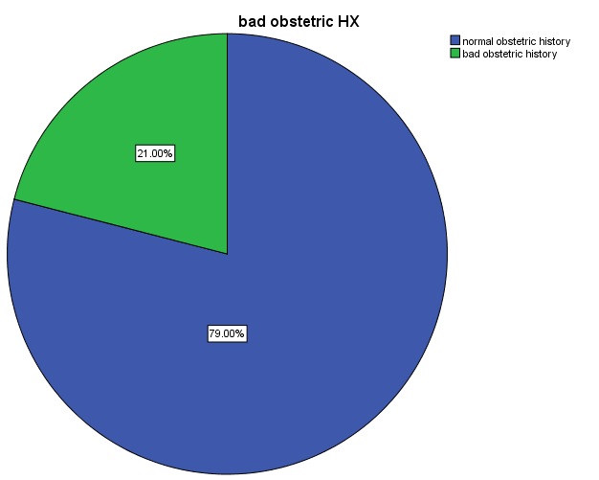

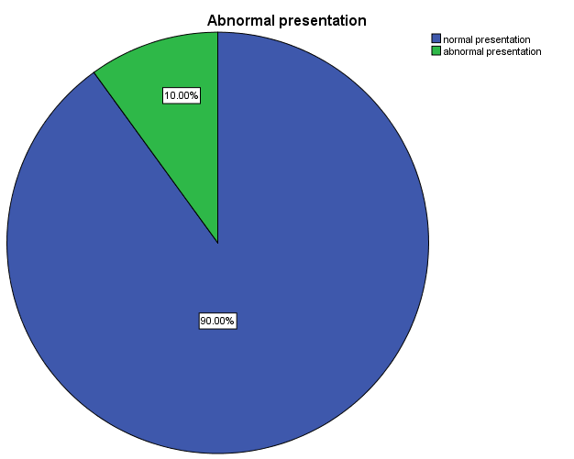

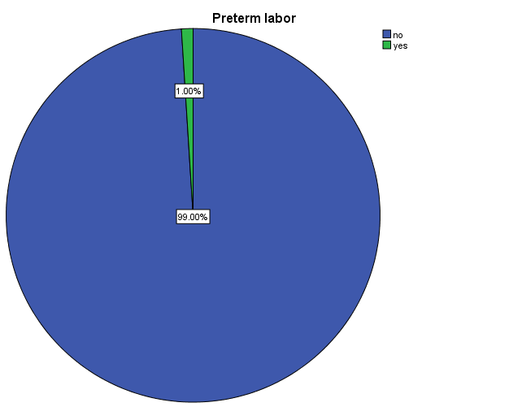

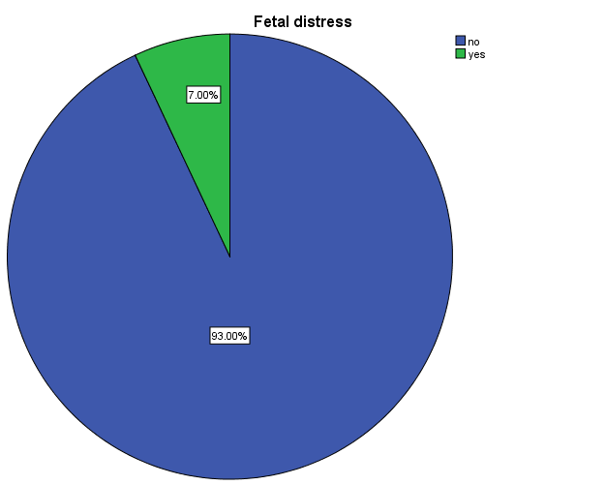

DISCUSSION
We reviewed 100 cases which underwent cesarean section for their indications. The most common indication was previous cesarean section, followed by abnormal presentation, followed by failure to progress then fetal distress and HT. . There were 40.00% cases with history of previous 2 cesarean sections. There were 10.00% cases operated for cesarean because of abnormal presentation ,8.00%dut to failure to progress,7.00%dut to fetal distress and same percent dut to HT,6.00%dut to CPD,5.00%post date,4.00%dut to bleeding ﴾about 1.00%dut to placenta previa﴿,3.00% dut to multiple pregnancy ,2.00%dut to precious baby and same percent dut to congental anomalies,1.00%for each of old primi ,preterm labour and oligohydrominous,0.00% dut to the other indications.

CONCLUSIONS
The rate of cesarean section has been increasing worldwide, due to various reasons and indications. There is a possibility of keeping the rate to minimum by reducing number of primary cesarean sections, by proper counselling of the patients, proper monitoring of maternal and fetal parameters, promoting institutional deliveries, promoting VBAC in previous CS cases with nonrecurrent indications.

REFERENCES
1.Ten Teachers,1917
2. World Health Organization. Appropriate technology for birth. Lancet. 1985;2(8452):436-7.
3. Hamilton BE, Martin JA, Ventura SJ. National Vital Statistics Reports. 2011;60,1. 4 . Belizan JM, Althabe F, Barros FC, Alexander S. Rates and implications of Cesarean Sections in Latin America: ecological study. BMJ. 1999;319:1397- 1402. 5. Hamilton BE, Ventura SJ, Martin JA, Sulton PD. Priliminary births for 2004: infant and maternal health. Health E-Stats. Released, 2005. 6. Stanton CK, Holtz SA. Studies in Family Planning, 2006. 7. Kambo I, Bedi N, Dhillon BS, Saxena AC. A critical appraisal of Cesarean section rates at teaching hospitals in India. Int J Gynaecol Obstet. 2002;79:151-8.

