SURGICAL TREATMENT OF PULMONARY TUBERCULOSIS

Objective : To show the indications and different options of surgical treatment of pulmonary tuberculosis.

Chemotherapy
Initial treatment continues for an average of 6 months in typical pulmonary T. B..
An effective treatment program converts the patient to a sputum-negative status within 6 weeks.

The five most commonly employed antimycobacterial drugs are listed in the table below.
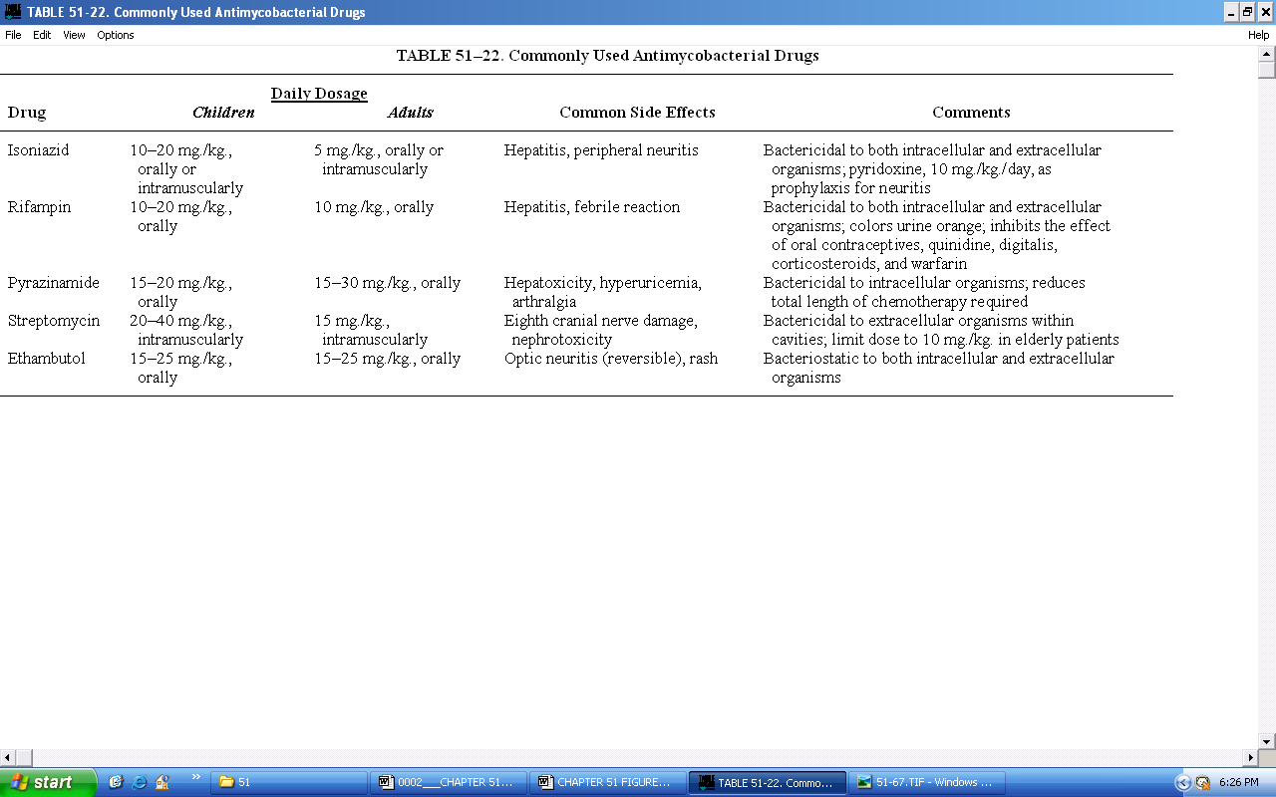

Surgical treatment
1-Pulmonary resection
It includes wedge resection, lobectomy or pneumoectomy.
2-Decorticatuon
3-Muscle flap transfer
4-Open drainage uncluding Eloesser flap procedure
5-Thoracoplasty

Indications for surgical intervention

- Persistently positive sputum cultures with cavitation after 5 to 6 months of continuous optimal anti - T. B. chemotherapy.

- Localized pulmonary disease caused by atypical mycobacterium or drug-resistant M. tuberculosis.

- When malignancy can not be excluded.

- Massive life-threatening hemoptysis or reccurent sever hemoptysis. Massive hemoptysis is defined as greater than 600 ml. per 24 hours, whereas severe hemoptysis is defined as greater than 200 ml. per 24 hours.

- A bronchopleural fistula that does not respond to tube thoracostomy.

- Tuberculous bronchiectasis of lower and middle lobes.

- Destroyed lung or lobe.

- Open negative cavities if thick walled or unreliable patient.

- Cavity containing mycetoma (aspergilloma).

- Trapped lung

- Relative indications for surgical intervention such as severe cavitation or bronchial stenosis.

