Dr.Methaq A.M. Hussein
MRCP(London)….assist.Professor

Causes of Hyperkalaemia
- Decreased or impaired potassium excretion – renal failure, potassium-sparing diuretics, urinary obstruction, sickle cell disease, Addison disease, and systemic lupus erythematosus (SLE)
- Additions of potassium into extracellular space - potassium supplements (eg, PO/IV potassium, salt substitutes), rhabdomyolysis, and hemolysis (eg, blood transfusions, burns, tumor lysis)
- Transmembrane shifts (ie, shifting potassium from the intracellular to extracellular space) - acidosis and medication effects (eg, acute digitalis toxicity, beta-blockers, succinylcholine)
- Factitious or pseudohyperkalemia - improper blood collection (eg, ischemic blood draw from venipuncture technique), laboratory error, leukocytosis, and thrombocytosis
ECG Changes
- From reduction of P wave amplitude and prolongation of PR interval to absence of P waves altogether.
- Increase of QRS duration.
- Increase of QT duration.
- Slowing of heart rate.
- T waves become tall and spiked.
- Decreased R wave amplitude

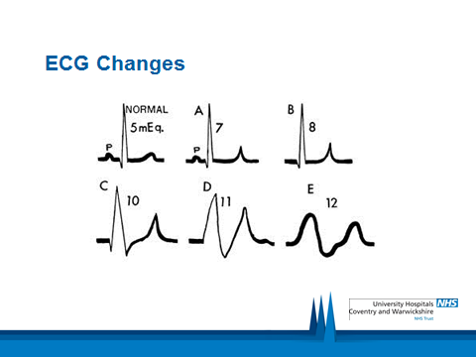

3 Principles of Treatment
- Stabilise myocardium
- Move it into cells
- Increase elimination
Dextrose – Insulin 1.
2.Calcium Gluconate
Sodium Bicarbonate 3.
Calcium Resonium 4.
- Salbutamol 5.
- 6.Furosemide
7.haemodialysis

HYPOKALEMIA

Causes of Hypokalemia
I. Decreased intake
A. Starvation
B. Clay Ingestion
II. Redistribution into Cells
A. Acid-Base (Metabolic Alkalosis)
B. Hormonal (Insulin, Beta agonist, Alpha )
C. Anabolic State (folic acid)
D. Other (Hypothermia, Pseudohypokalemia
III. Increased Loss
A. Nonrenal
1. Gastrointestinal Los
2. Integumentary Loss (sweat)
B. Renal

SIGNS & SYMPTOMS
Fatigue
Myalgia
Muscular weakness & paralysis
Hyporeflexia
Dyspnea
Arrhythmia
Predispose to digitalis toxicity
Constipation
ECG changes
Due to delayed ventricular repolarization
Early changes: flattening or inversion of T wave, prominent U wave, ST-segment depression, prolonged QU interval
Severe K+ depletion: prolonged PR interval, decreased voltage and widening of QRS complex

Calcium
Body requirements
- Age (in years) Calcium Requirement
- 1 – 3 500mg
- 4 - 8 800mg
- 9 - 18 1300mg
- 19 - 50 1000mg
- 51+ 1500mg
*Pregnant and lactating women are recommended a daily calcium intake of 1000mg
Calcium in the plasma:
Only 1%
45% in ionized form (the physiologically active form)
45% bound to proteins (predominantly albumin)
10% complexed with anions (citrate, sulfate, phosphate)
To estimate the physiologic levels of ionized calcium in states of hypoalbuminemia:
[Ca⁺²]_{Corrected} = [Ca⁺²]_{Measured} + [ 0.8 (4 – Albumin) ]

Hypercalcemia
Increased GI Absorption:
Vitamin D excess
Elevated PTH

Decreased Urinary Excretion:
Thiazide diuretics
Increased Loss From Bone:
Elevated PTH
Hyperparathyroidism
Malignancy
Osteolytic metastases
Complication:
Metastatic calcification
Renal stones
Treatment of hypercalcaemia:
Saline/fluid hydration :
--increases renal calcium excretion
---2 to 4 L IV daily for 1 to 3 days
Biphosphonates :
---inhibition bone resorption
---Pamidronate (Aredia), 60 to 90 mg IV over 4 hours
Calcitonin :
----inhibition bone resorption and increases renal calcium excretion
----4 to 8 IU per kg IM or SQ every 6 hours for 24 hours
Plicamycin (Mitharmycin) :
----decreases bone resorption
----25 mcg per kg per day IV over 6 hours for 3 to 8 doses
Gallium nitrate :
-----inhibition bone resorption
-----100 to 200 mg per m2 IV over 24 hours for 5 days
Glucocorticoids :
----Inhibits vitamin D conversionto calcitriol
-----Hydrocortisone, 200 mg IV daily for 3 days
Hemodialysis :
---used in patients with renal failure

- Hypocalcaemia
- Is a condition in which the calcium level below
- The normal level
- Is caused by low level of PTH , low level of magnesium, deficiency of vitamin D
- The kidney dysfunction play role in hypocalcuimia
Etiology of the hypocalcemia
- Decreased GI Absorption
- Poor dietary intake of calcium,impair absorption
- Increased Urinary Excretion
- Decreased Bone Resorption/Increased Mineralization
- Low PTH
- PTH resistance
Vitamin D deficiency
Tetany
