L.1 Dr. Roua Al yaseen

Central nervous system (CNS) congenital malformations

Neural tube defects
Neural tube defects (NTDs) are commonest congenital anomalies of the CNS and result from failure of the neural tube to close spontaneously between the 3rd and 4th wk. of in utero development

Etiology
- Unknown,
- Hyperthermia
- Drugs (valproic acid)
- Malnutrition
- Low red cell folate levels
- Maternal obesity or diabetes
- Genetic determinants (mutations in Folate-responsive or folate-dependent enzyme pathways)
- Exposure to radiation before conception.

Prenatal screening
Prenatal screening of maternal serum for AFP in the 16th-18th wk of gestation is an effective method for identifying pregnancies at risk for fetuses with NTDs in utero.

1. Spina bifida occulta
is a common anomaly consisting of a midline defect of the vertebral bodies without protrusion of the spinal cord or meninges. Most patients are asymptomatic and lack neurologic signs, This simple defect does not have an associated spinal cord malformation but there are cutaneous manifestations such as a hemangioma, discoloration of the skin, lump ,dermal sinus, or hairy patch. All cases are best investigated with MRI.

2.Meningocele
A meningocele is formed when the meninges herniate through a defect in the posterior vertebral arches or the anterior sacrum. Most meningoceles are well covered with skin Careful neurologic examination is mandatory.
Orthopedic and urologic examination should also be considered. In asymptomatic children with normal neurologic findings and full-thickness skin covering the meningocele, surgery may be delayed or sometimes not performed.

3. Myelomeningocele
Myelomeningocele represents the most severe form of dysraphism , so called open form , involving the vertebral column and spinal cord.

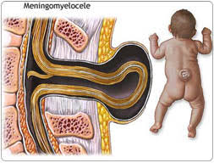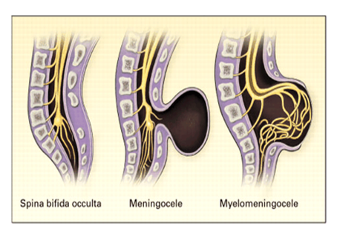

CLINICAL MANIFESTATIONS
Myelomeningocele produces dysfunction of skeleton, skin, and gastrointestinal and genitourinary tracts, peripheral nervous system and the CNS.
A myelomeningocele located in lumbosacral region accounts for at least 75% of the cases. A lesion in the low sacral region causes bowel and bladder incontinence.

Examination of the infant shows a flaccid paralysis of the lower extremities, an absence of deep tendon reflexes, a lack of response to touch and pain, and a high incidence of lower-extremity deformities (clubfeet, ankle and /or knee contractures , and subluxation of the hips)
Patients with a myelomeningocele in the upper thoracic or the cervical region usually have a very minimal neurologic deficit and, in most cases .

TREATMENT
Management and supervision of a child and family with a myelomeningocele require team approach, including surgeons, other physicians, and therapists, with a pediatrician

1-Surgery : repair of a myelomeningocele is often done within a day of birth but can be delayed for several days (except when there is a CSF leak).
2- Shunting procedure for hydrocephalus if present.
3- Clubfeet may require casting.

4-Careful evaluation of the genitourinary system, & regularly catheterize a neurogenic bladder to prevents urinary tract infections and reflux leading to pyelonephritis , hydro nephrosis , and bladder damage.

PROGNOSIS
For a child who is born with a myelomeningocele and who is treated aggressively, the mortality rate is 10-15%, and most deaths occur before age 4 yr. At least 70% of survivors have normal intelligence, but learning problems and seizure disorders are more common than in the general population. Renal dysfunction is one of the most important determinants of mortality.

Prevention
All women of childbearing age take 0.4 mg of folic acid daily. If high-risk women (previously affected child), supplementation should be started with
4 mg of folic acid daily, beginning 1 mo before pregnancy. Certain drugs, including drugs that antagonize folic acid such as trimethoprim and the anticonvulsants (carbamazepine, phenytoin & phenobarbital) increase the risk of myelomeningocele if administered during pregnancy.

4.Encephalocele
Protrusion of tissue through a bony midline defect (commonly in the occipital region ).a cranial encephalocele contains the sac plus cerebral cortex, cerebellum, or portions of the brainstem. Infants with a cranial encephalocele are at increased risk for developing hydrocephalus .
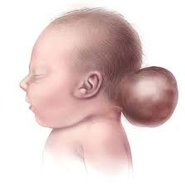

5.Hydrocephalus
Hydrocephalus is not a specific disease; it represents a diverse group of conditions that result from impaired circulation and absorption of CSF .

Physiology:
The CSF is formed primarily in the ventricular system by the choroid plexus, which is situated in the lateral, 3rd, and 4th ventricles.
The total volume of CSF approximates 50 mL in an infant and 150 mL in an adult. Intraventricular pressure is 180 mm H₂O.

Hydrocephalus resulting from obstruction within the ventricular system is called obstructive or noncommunicating hydrocephalus. The CSF then circulates from the basal cisterns over the convexities of the cerebral hemispheres & absorbed by the arachnoid villi.

If it is resulting from obliteration of the subarachnoid cisterns or malfunction of the arachnoid villi is called nonobstructive or communicating hydrocephalus.

Etiology
Obstructive hydrocephalus( noncommunicating) :
1-Aqueductal stenosis
- Infectious(meningitis)
-neurofibromatosis
2-Lesions or malformation of posterior fossa like tumor, Chiari malformation, Dandy-Walker malformation.
3-Mass lesions ( Abscess, Hematoma, Tumors and neurocutaneous disorders.

Communicating hydrocephalus:
1-Meningitis (Pneumococcal and tuberculous meningitis) due to produce a thick, exudate that obstructs the basal cisterns.

2-Subarachnoid hemorrhage because blood in the subarachnoid spaces cause obliteration of the cisterns or arachnoid villi and obstruction of CSF flow.

3- Leukemic infiltrates.
4- Choroid plexus papilloma.
5- Achondroplasia.

Clinical manifestations
It is variable and depends on many factors, including the age at onset, the nature of the lesion causing obstruction, and the duration and rate of increase of the intracranial pressure (ICP).
In infants:
- Accelerated rate of enlargement of the head is the most prominent sign.
- The anterior fontanel is wide open and bulging, and the scalp veins are dilated.
- The forehead is broad, and the eyes deviate downward, producing the setting-sun sign.
- Long-tract signs including brisk tendon reflexes, spasticity, clonus (particularly in the lower extremities), and Babinski sign are common.

In older child
The cranial sutures are partially closed so that the signs of hydrocephalus may be subtler.
- headache is a prominent symptom in older patients.

- Irritability, lethargy, poor appetite, and vomiting are common .
- A gradual change in personality and a deterioration in academic productivity suggest a slowly progressive form of hydrocephalus.

By examination:
1-Serial measurements of the head circumference(OFC) indicate an increased velocity of growth.
2-Percussion of the skull may produce a cracked pot sound or Macewen sign, indicating separation of the sutures.
3-Papilledema, abducens nerve palsy, and pyramidal tract signs mainly in the lower extremities, are apparent in most cases.

- Chiari malformation: consists of two major subgroups.
Type I typically produces symptoms during adolescence or adult life and is usually not associated with hydrocephalus. Patients complain of recurrent headache, neck pain, urinary frequency, and progressive lower extremity spasticity. The deformity consists of displacement of the cerebellar tonsils into the cervical canal.

Type II Chiari malformation is characterized by progressive hydrocephalus with a myelomeningocele. This lesion represents an elongation of the 4th ventricle and kinking of the brainstem, with displacement of the inferior vermis, pons, and medulla into the cervical canal. Symptoms during infancy consisting of stridor, weak cry, and apnea.

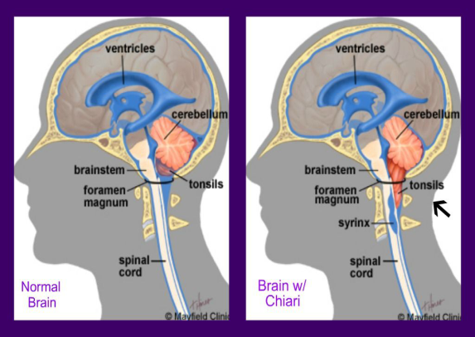

- Dandy-Walker malformation consists of a cystic expansion of the 4th ventricle in the posterior fossa. 90% of patients have hydrocephalus.

6.Anencephaly

Large defect of the calvarium, meninges, and scalp associated with a rudimentary brain.The cerebral hemispheres and cerebellum are usually absent, and only a residue of the brainstem can be identified.

The pituitary gland is hypoplastic, folding of the ears, cleft palate, and congenital heart defects in 10-20% of cases. Most anencephalic infants die within several days of birth.

