Republic of Iraq
Ministry of Higher Education and Scientific Research
Thi-qar University
College Of Medicine
Internal Medicine Department
PREVELANCE OF DIABETES MELLITUS TYPE 2 IN DIALYSIS PATIENT AND ITS RELATION TO TYPE OF TREATMENT IN THI QAR AT 2019

This study was submitted in partial fulfillment of the requirements for the M.B.Ch.B
By
NOOR ABD-ALKAREEM
HEDOAA MOHAMMED

Supervised By
Dr. Methaq Abd AL Mahdi

ACKNOWLEDGEMENTS

Prima facie, we are grateful to the God for the good health and wellbeing that were necessary to complete this study.
We would like to show our gratitude to our supervisors for sharing their pearls of wisdom with us during the course of this study.
We thank the members of community medicine department for assistance with methodology and for comments that greatly improved the manuscript.
We take this opportunity to express gratitude to all of the Department faculty members for their help and support .we thank our parents for the unceasin encouragement, support and attention.

 Contents
- Abstract
- Introduction
- Methods
- Results
- Discussion
- References

ABSTRACT
BACKGROUND: Chronic kidney disease (CKD) became a new epidemic of the twentieth and twenty-first centuries. Diabetic nephropathy is one of the leading causes of end-stage renal failure as a result of the diabetes epidemic worldwide.
AIM: The aim of our study was to assess the prevalence of CKD in diabetic patient and its association with type of anti diabetic.
MATERIALS AND METHODS: The study was a part of a study screening for early detection of kidney disease. It was a cross-sectional study based on a random sample of patients aged > 20, consecutively consulting their primary physician for any cause. Fifty physicians throughout the country were included in the study. A total of 50 patients have been analyzed based on integrity data. GFR was estimated using corrected values of serum creatinine and calculating kidney function by the Cockroft&Gault formula, adjusted for body surface using the Gehan& George formula. Patients with estimated glomerular filtration rate (eGFR) less than 60 ml/min were considered as having CKD. Blood pressure, body weight, height, serum creatinine, glucose, hemoglobin, hematocrit, urinalysis and medical history for presence of cardiovascular diseases or diabetes were also assessed.
RESULTS: The mean age of the subjects was 25 to 85 and most of patient were older than 65. Regarding gender, 59% were females. Subjects with CKD (eGFR less than 60 ml/min) were 7.53% of the total. Subjects aged 60 or above, had 20 times higher risk of having CKD (eGFR less than 60 ml/min/1.73 m2). Out of the total group of subjects, 13.9% had diabetes mellitus and they had 3.13 times higher risk of having CKD stage 3-5 (eGFR less than 60 ml/min/1.73 m2) when compared to non-diabetics. The results showed that diabetes was significantly more associated with lower eGFR (less than 60 ml/min/1.73 m2) in younger subjects (age less than 60) compared to older ones (odds ratio 3.29 versus 1.21).
CONCLUSION: the CKD continued to be prevalent in DM type2 population. Prevalence remained fairly consistent over time, suggesting that many efforts to prevent CKD could be improved overall. Especially by monitoring certain population more closely.

Introduction
Chronic kidney disease (CKD) became a new epidemic of the twentieth and twenty-first centuries. At present, it is a global problem, mainly because a variety of risk factors are being involved in its etiology and pathophysiology. It is not surprising that diabetic nephropathy is one of the leading causes of end-stage renal failure having in mind the diabetes epidemic worldwide [1].
The prevalence of CKD differs among countries and ethnicities. It is of great importance for the policy makers to know the prevalence of CKD, as it is associated with high morbidity and mortality and high cost of renal replacement therapy. Guidelines
from the National Kidney Foundation’s Kidney Disease Outcomes Quality Initiative (KDOQI) recommend estimating glomerular filtration rate and screening for albuminuria in patients with risk factors for chronic kidney disease, including diabetes, hypertension, systemic illnesses, age greater than 60 years, and family history of chronic kidney disease. The glomerular filtration rate (GFR), calculated by using a prediction equation, detects chronic kidney disease more accurately than does the serum creatinine level alone; the GFR also is used for disease staging. Current KDOQI guidelines recommend screening for kidney disease with a serum creatinine measurement for use in GFR estimation and analysis of a random urine sample for albuminuria [2].
The prevalence of CKD has increased dramatically in the period of 1999 to 2007 in different countries around the world, developed, as well as developing countries. It has reached epidemic proportions with 10–13% of the populations in Taiwan, Iran, Japan, China, Canada, India and the USA [3].
The aim of this paper was to estimate the prevalence of CKD in Thi qar and the association of diabetes mellitus in patients with CKD and its relation to type of treatment.

Materials and Methods
This study is part of a study conducted from November 2018 to May 2019 in terms of screening for early detection of kidney disease (SKROBB). It was a cross-sectional study based on a random sample of patients aged > 20, consecutively consulting their primary physician for any cause. Fifty physicians throughout the country were included in the study. A total of 50 patients were included. The physicians were asked to fill in a questionnaire for demographic and medical history data. They were also required to measure blood pressure, body weight, height, serum creatinine, glucose, hemoglobin, hematocrit and urinalysis. Proteinuria (qualitatively, 1+ or more), and/or hematuria, and estimated glomerular filtration rate (eGFR) < 60 ml/min per 1.73 m2 have been considered as markers of renal damage or of chronic kidney disease. Serum creatinine has been measured by the use of Jaffe’s method, and in order to minimize the differences among alkaline picrate methods regarding influence of protein on creatinine results, at least in 10% of all the samples of each laboratory creatinine has been measured at the reference laboratory . A correction factor for creatinine has been estimated in each laboratory in the country. The body surface area has been measured using the Gehan& George formula [4]. The eGFR has been estimated using the Cockroft&Gault formula (Calculated creatinine clearance = [(140-age) x 1.23 x BW(kg)/Scr ] x 0.85 if female). Gender, age, presence of cardiovascular diseases, hypertension, diabetes, anemia, and obesity (BMI) has been considered as risk factors for CKD. Hypertension was defined as systolic blood pressure (SBP) >140 mmHg and diastolic blood pressure > 90 mmHg or having medical history or being treated for hypertension [5]. Persons were considered diabetic if fasting blood glucose was more than 7.1 mmol/l, or having medical history or being treated for diabetes [6].
The prevalence of CKD was calculated after adjustment for age and gender to the general population .
Stage 1 and Stage 2 CKD was considered on the basis of proteins in the urine (1+ or more) without evidence of urinary infection.
Statistical analysis has been conducted using the software program Statistica for Windows 10.0. Student-t test was used to compare the numerical data. Mantel-Haenszel Chi-square test was used to see the relationship between two dichotomous variables.

RESULTS
Statistics
 |  | age | durationofDM | sex
N | Valid | 50 | 50 | 50
 | Missing | 0 | 0 | 0

age
 |  | Frequency | Percent  age | Valid Percent | Cumulative Percent
Valid | 25-45 | 2 | 4.0 | 4.0 | 4.0
 | 45-65 | 23 | 46.0 | 46.0 | 50.0
 | more 65 | 25 | 50.0 | 50.0 | 100.0
 | Total | 50 | 100.0 | 100.0

durationofDM
 |  | Frequency | Percent | Valid Percent | Cumulative Percent
Valid | less 5 year | 17 | 34.0 | 34.0 | 34.0
 | 5-10 years | 11 | 22.0 | 22.0 | 56.0
 | more 10 years | 22 | 44.0 | 44.0 | 100.0
 | Total | 50 | 100.0 | 100.0

sex
 |  | Frequency | Percent | Valid Percent | Cumulative Percent
Valid | male | 21 | 42.0 | 42.0 | 42.0
 | female | 29 | 58.0 | 58.0 | 100.0
 | Total | 50 | 100.0 | 100.0

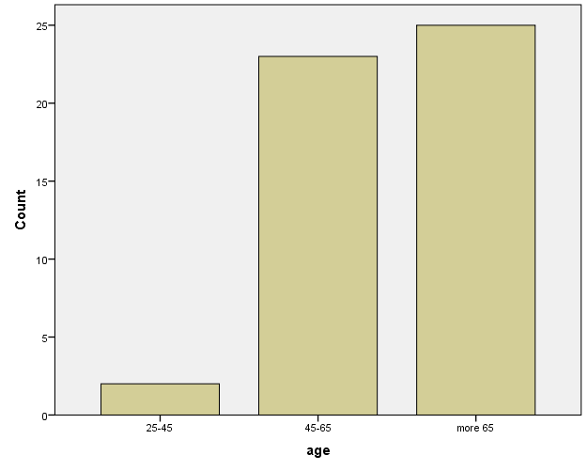

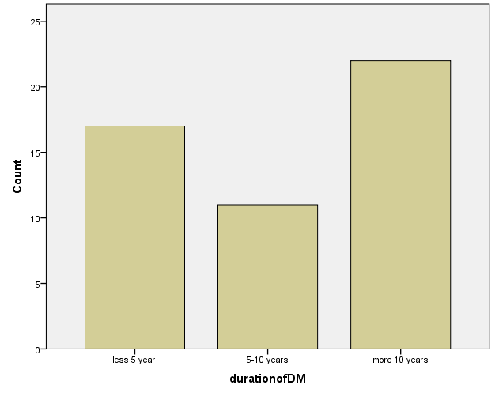

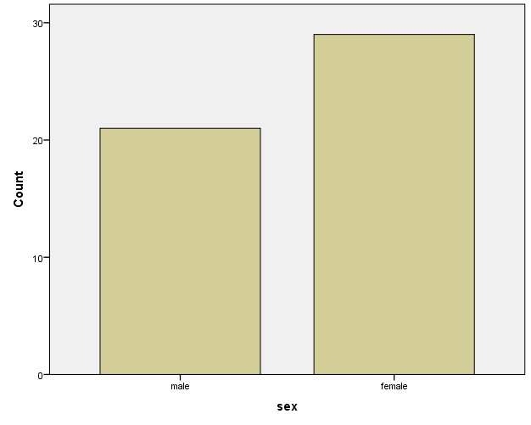

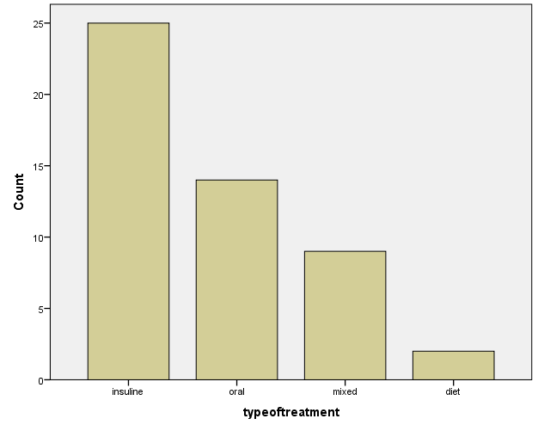

DISCUSSION
Data on the epidemiology of CKD in predialysis stages exists only in a small minority of countries in Iraq . So, there is lack of information on prevalence of CKD in the different stages in different countries [7]. The available studies from the USA, Europe, Australia, and Asia showed that the prevalence of CKD is about 9–13% in the general population. The incidence and prevalence of patients with CKD including end-stage renal disease (ESRD) have doubled in the past 10 years and it is increasing not only among adults in the United States but also worldwide [8-10]. The incidence and prevalence of CKD increase markedly at older age [9, 11]. For example, in the Framingham Heart Study, the risk of developing stage 3 CKD was 2.36 times higher for each 10 years older age [11]. Additionally, the prevalence of stage 1 or 2 and stage 3 or 4 CKD among US adults has been reported to be 3.3 and 54 times higher, respectively, for adults ≥70 versus 20 to 39 years of age [9]. Our study also showed a strong correlation of age and CKD (20 times greater risk of having CKD if a subject is 60 years of age or older).
In the study of Islam T. et al[12] , for adults 25 to 45, 45 to 65 and ≥ 65 years of age, the prevalence ratios (95% confidence interval) of stage 3 or 4 CKD associated with diagnosed diabetes mellitus were 3.01 (1.35 – 6.74), 1.61 (1.15 – 2.25), 1.40 (1.15 – 1.69), respectively. Our study also showed strong correlation of diabetes mellitus and CKD, Subjects had 3 times higher risk of having CKD stage 3-5 if being a diabetic. Age in diabetic subjects was a confounding variable for having CKD in our study. Subjects with DM and older than 60 had 1.2 higher risk of having CKD, compared to those with DM and younger than 60 (who had 3.3 times higher risk of having CKD).

This study has two limitations. The study population were patients consecutively consulting their general physician for any reason, and not subjects from the general population. Therefore, a possible selection bias must be considered. The high number of patients with diabetes mellitus in the study population points out to this notion. Secondly, stage 1 and 2 CKD were defined by qualitative measurement of protein in the urine, and not by albuminuria or albumin/creatinine ratio. Therefore, the presence of CKD stage1 and 2 may not be completely accurate. Hence, to show the association of age and diabetes with CKD, we take into consideration only CKD stage 3-5 (eGFR less than 60 ml/min/1.73 m2).

In conclusion, our study showed that chronic kidney disease is frequent and is associated with risk factors as older age and diabetes. Diabetes mellitus is associated with stage 3 to 5 CKD across the full adult age range. But, this association was statistically significantly stronger at younger.

REFERANCE
1-Singh AK, Coyne D. Chronic Kidney Disease. In: Educational Review Manual in Nephrology. eds Singh A.K. PPG Ltd, New York, 2007.

2-The National Kidney Foundation. K/DOQI clinical practice guidelines for chronic kidney disease: evaluation, classification, and stratification. Am J Kidney Dis. 2002;39:S1–266. PMid:11904577

3- Stenvinkel P. Chronic kidney disease: a public health priority and harbinger of premature cardiovascular disease. Journal of Internal Medicine. 2010;268:456-467. http://dx.doi.org/10.1111/j.1365-2796.2010.02269.x PMid:20809922

4-Gehan EA, George SL. Estimation of human body surface area from height and weight. Cancer Chemother Rep. 1970;54:225–35. PMid:5527019

5-Chobanian AV, Bakris GL, Black HR, Cushman WC, Green LA, Izzo JL, Jones Jr DW, Materson BJ, Oparil S, Wright JT, Roccella Jr EJ, and the National High Blood Pressure Education Program Coordinating Committee. SEVENTH REPORT OF THE JOINT NATIONAL COMMITTEE ON PREVENTION, DETECTION, EVALUATION, AND TREATMENT OF HIGH BLOOD PRESSURE Downloaded from http://hyper.ahajournals
.org/ on January 12, 2016.

6-Schneider H, Shaw J, Zimmet P. Guidelines for the Detection of Diabetes Mellitus – Diagnostic Criteria and Rationale for Screening. Clin Biochem Rev. 2003; 24(3):77-80. PMid:18568047 PMCid:PMC1853340

7-Zoccali C, Kramer A, Jager K. Epidemiology of CKD in Europe: an uncertain scenario. Nephrol Dial Transplant. 2010;25:1731–1733. http://dx.doi.org/10.1093/ndt/gfq250 PMid:20501467

8-Coresh J, Astor BC, Greene T, Eknoyan G, Levey AS. Prevalence of chronic kidney disease and decreased kidney function in the adult US population: Third National Health,
Nutrition Examination Survey. Am J Kidney Dis. 2003;41(1):1–12. http://dx.doi.org/10.1053/ajkd.2003.50007 PMid:12500213

9-Coresh J, Selvin E, Stevens LA, Manzi J, Kusek JW, Eggers P, Van Lente F, Levey AS. Prevalence of chronic kidney disease in the United States. Jama. 2007;298(17):2038–2047. http://dx.doi.org/10.1001/jama.298.17.2038 PMid:17986697

10-Meguid El Nahas A, Bello AK. Chronic kidney disease: the global challenge. Lancet. 2005;365(9456):331–340. http://dx.doi.org/10.1016/S0140-6736(05)17789-7

11- Fox CS, Coady S, Sorlie PD, Levy D, Meigs JB, D'Agostino RB Sr, Wilson PW, Savage PJ. Trends in cardiovascular complications of diabetes. Jama. 2004;292(20):2495–2499. http://dx.doi.org/10.1001/jama.292.20.2495 PMid:15562129

12- Isalm TM, Fox CS, Mann D, Muntner P. Age-related Associations of Hypertension and Diabetes Mellitus with Chronic Kidney Disease. BMC Nephrology. 2009;10:17. http://dx.doi.org/10.1186/1471-2369-10-17
PMid:19563681 PMCid:PMC2714514

