بسم الله الرحمن الرحيم

SOME OF RISK FACTORS AND CLINICAL PRESENTATION OF COPD PATIENTS ADMITTED TO AL-HUSSAIN TEACHING HOSPITAL AT 2018-2019
Thesis done as part of graduation requirement from college of medicine –Thiqar university
DONE BY
Norhan Hameed Hussein
Donya Raji Faisal
Superviser
Dr Majeed Mohan Alhamami
FIBMS MACP

ABSTRACT

Background :Chronic obstructive pulmonary disease (COPD) has been a major public health problem during the 20th century, and will remain a challenge for the foreseeable future. Worldwide, COPD is in the spotlight, because its high prevalence, morbidity, and mortality create formidable challenges for healthcare systems. However, there remain many ongoing, contentious issues in COPD, including the definition, staging of COPD itself , pathophysiology and risk factors.
Objective: To understand the correlation between certain risk factors and clinical presentation of chronic obstructive pulmonary disease (COPD)
Methods: longtudInal study use for this research beginning from 1/11/2018 to 28/2/2019 on 63 patient with COPD their age ( 25_89) years old acorrding what we find that admitted to al-Hussain teaching hospital
Results: the age,gender,adress and smoking are very effective risk factors on copd
And most patient presente as cough with dyspnea and seputum production.

AKNOWLDGMENT
Firstly to to Allah Alrahman Alraheem
To the superviser our father and teacher dr. Majeed Alhamami
To my family father ,mother ,the others
To the resident in respiratory center and medicine deparment
To nurses
To patients

Introduction

Chronic Obstructive Pulmonary Disease
Definition
Is common,preventable and treatable disease that is charactrized by persistant respiratory symptom and airflow limitation due to airway and alveolar abnormalities usually by significant exposure to noxious particles or gases.

Epidemiology
COPD is one of the leading causes of death worldwide, with the prevalence of 5.6% (3.2 million) in 2015 projected to increase to 7.8% by 2030.¹ The consequent socioeconomic burden of COPD is high, causing reduced quality of life (QOL), loss of productivity, increased hospital admissions and premature mortality. One important and cost-effective intervention is smoking cessation.² ³ However, increasing importance is placed on improving risk factors and slowing down disease progression by addressing non-pulmonary aspects of the condition.^{4–8} Spirometry is the most widely used marker of disease severity and progression. No longer is it believed that all patients will worsen over time with increasing airflow limitation. Clinicians have now identified that COPD is heterogeneous and existing measures such as FEV1 may fail to capture systemic disease⁹ and have divergent trajectories.¹⁰COPD also leads to systemic problems, such as skeletal muscle weakness and cardiovascular disease, the latter accounting for a third of deaths in COPD.¹¹ While multiple studies have shown that quadriceps involvement in COPD is associated with worse outcomes,^{12–14}
RISK FACTOR
There are comprehensive lists of risk factors associated with the development and triggering of COPD exacerbations, the recent literature is packed with reports aimed at explaining COPD apart from smoking. Other than tobacco smoking, risk factors for developing COPD are being increasingly recognized ⁽¹⁵⁾, and include many other environmental exposures, such as occupational exposures to dust and fumes in the developed and developing countries ⁽¹⁶⁾, and indoor biomass fuel burning in many developing countries ⁽¹⁷⁾. Reduction of such exposures on a population basis or at an individual level might be worthwhile. Factors that seem to be less important in the development of COPD, although they may worsen disease, include outdoor pollutants and passive smoke exposure. A number of factors associated with COPD development may not currently be possible to modify; these include the aging lung, sex, comorbidities, and child or adult repeated respiratory infections. The best-known genetic factor linked to COPD is α1-antitrypsin deficiency (α1-ATD), which arises in up to 3% of patients with COPD and, combined with smoking, increases the risk of panlobular emphysema ⁽¹⁸⁾.

Diagnosis
Spirometric evaluation is required for the clinical diagnosis of
COPD. Spirometry is warranted in any patient presenting with
dyspnea, chronic cough, or sputum production. Screening for
COPD with spirometry should not be performed in asymptomatic
patients.
For diagnosis of COPD, spirometry should be performed

both before and after administration of an inhaled bronchodilator. A postbronchodilator fixed FEV/FVC ratio less than 70% is diagnostic for COPD in a consistent clinical context and differentiates COPD from asthma, which shows reversible airflow obstruction.

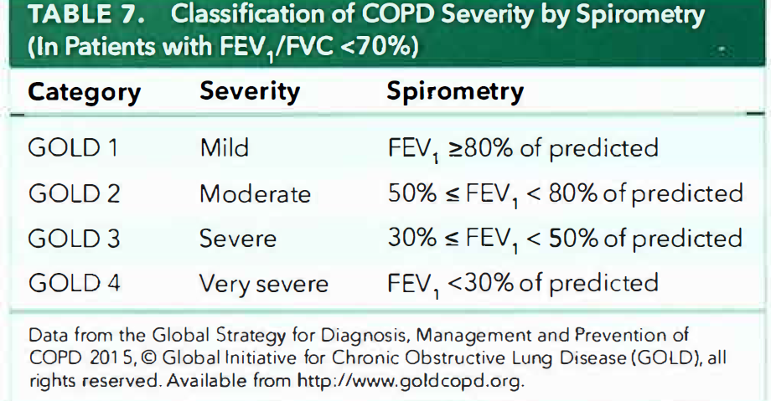

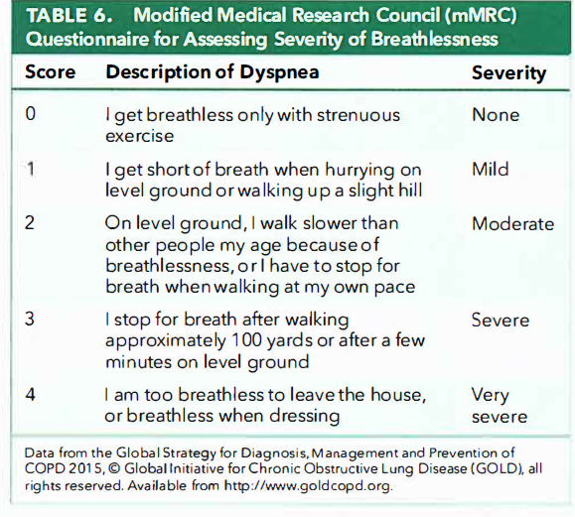

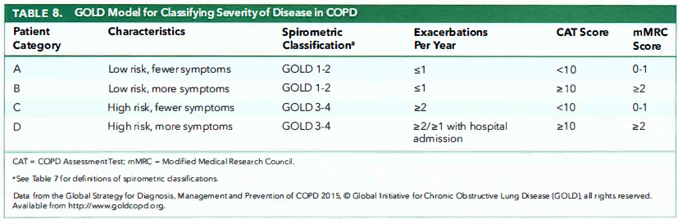
Acute Exacerbations
Definition:
An exacerbation of COPD is defined as a sustained worsening
of the patient's COPD. Exacerbations are marked by increased
breathlessness and are usually accompanied by increased
cough and sputum production. The degree of exacerbation is
considered mild when a change in the clinical condition is
noted but no change in medication is necessary. An exacerbation
is considered moderate when medication changes are
made. A severe exacerbation results in hospitalization
Prevention
The strongest predictors of exacerbation are: (1) a history of
previous exacerbation and (2) the baseline severity of airflow
limitation. However, exacerbations of COPD can be prevented
by optimizing treatment with appropriate interventions based
on risk classification and overall disease management; this
includes immunizations and lifestyle changes such as maintaining
physical activity and addressing anxiety and depression.
Interruption of maintenance therapy for COPD is associated
with an increased risk of exacerbation. Smoking cessation
has the greatest capacity to influence the natural history of
COPD and reduce future exacerbations; therefore, all measures
)including counseling and pharmacologic support(
should be given to assist patients in stopping smoking.
Exacerbations may also commonly be precipitated by respiratory
infections (either bacterial or viral), and efforts should be
made to minimize exposure to possible sources of infection.
Additionally, environmental exposures, such as to pollutants,
may trigger exacerbations and should be avoided.
In patients who experience an exacerbation, early outpatient
pulmonary rehabilitation is safe and produces clinically
significant improvements in health status at 3 months, possibly
decreasing the risk of future exacerbations.
Objective

Firstly as part of requirments of graguation
Then
To understand the correlation betweensoome of risk factors and clinical presentation of chronic obstructive pulmonary disease (COPD)..

methedology

cross_sectional study use for this research beginning from 1/11/2018 till 1/3/2019 on 63 patient with COPD in age( 25_89) years old acorrding what we find that admitted to al-Hussain teaching hospital . first we created specific questionnaire which include specail data about COPD then was filled after asking the patients and check vital sign of patients (RR,PR ,TEMP,BP) then examination include chest and and spirometry done for them ,if they not doing already to confirm copd this done by visiting hospital during official working hours for about 5 month..
- Inclusion :
That patient accept the study and cmplete quastionneare and investigation.
- Exclusion :patien that not accept the study and not complet it
RESULT
Aga
 |  | Frequency | Percent | Valid Percent | Cumulative Percent
Valid | less than 45 (young) | 7 | 11.1 | 11.1 | 11.1
 | 45_62(middle age) | 25 | 39.7 | 39.7 | 50.8
 | more than 63(old) | 31 | 49.2 | 49.2 | 100.0
 | Total | 63 | 100.0 | 100.0
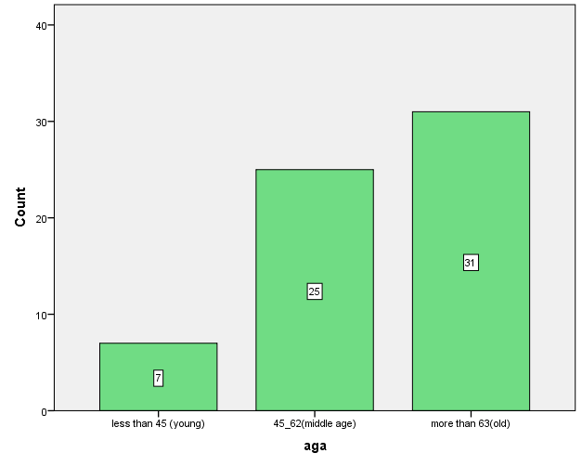
type of sex male or female
 |  | Frequency | Percent | Valid Percent | Cumulative Percent
Valid | Male | 35 | 55.6 | 55.6 | 55.6
 | female | 28 | 44.4 | 44.4 | 100.0
 | Total | 63 | 100.0 | 100.0
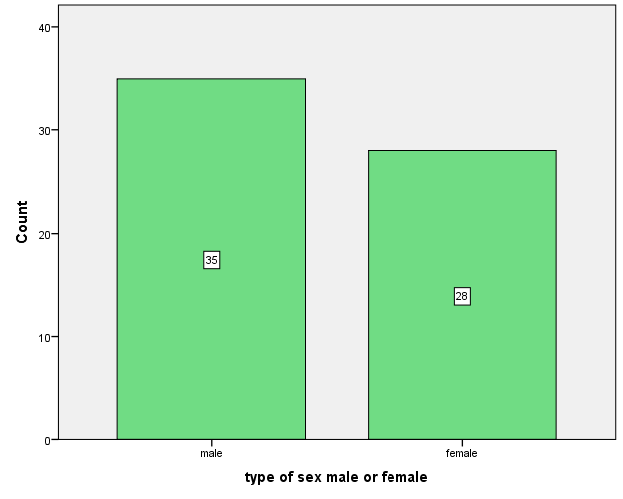

Adress
 |  | Frequency | Percent | Valid Percent | Cumulative Percent
Valid | Rural | 33 | 52.4 | 52.4 | 52.4
 | urban | 30 | 47.6 | 47.6 | 100.0
 | Total | 63 | 100.0 | 100.0
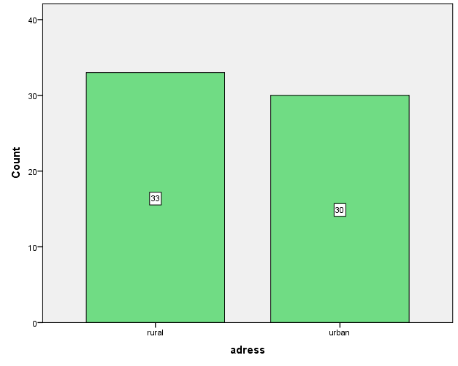
Residentinruralarea
 |  | Frequency | Percent | Valid Percent | Cumulative Percent
Valid | No | 9 | 14.3 | 14.3 | 14.3
 | yes(iess than 40) | 20 | 31.7 | 31.7 | 46.0
 | yes(more than 40) | 34 | 54.0 | 54.0 | 100.0
 | Total | 63 | 100.0 | 100.0
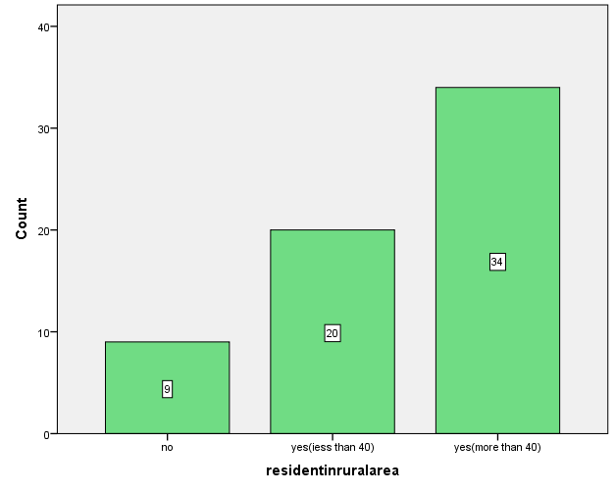
Smoker
 |  | Frequency | Percent | Valid Percent | Cumulative Percent
Valid | Yes | 60 | 95.2 | 95.2 | 95.2
 | No | 3 | 4.8 | 4.8 | 100.0
 | Total | 63 | 100.0 | 100.0

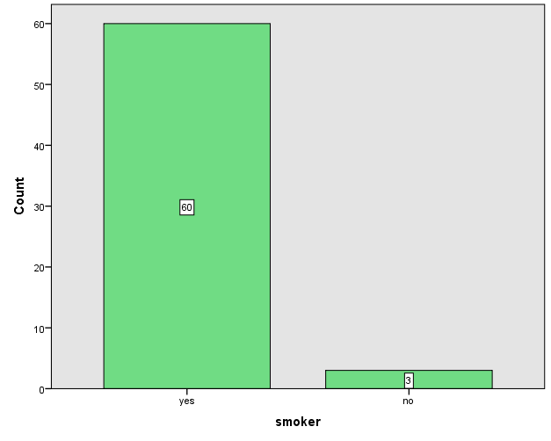
Packperyear
N | Valid | 63
 | Missing | 0
Mean |  | 70.24
Median |  | 60.00
Std. Deviation |  | 47.798
Skewness |  | 1.791
Std. Error of Skewness |  | .302
Range |  | 250
Minimum |  | 0
Maximum |  | 250
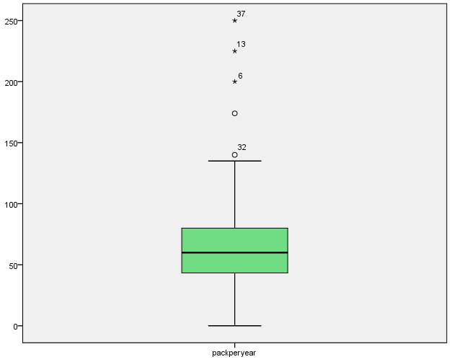
Cough
 |  | Frequency | Percent | Valid Percent | Cumulative Percent
Valid | Yes | 61 | 96.8 | 96.8 | 96.8
 | No | 2 | 3.2 | 3.2 | 100.0
 | Total | 63 | 100.0 | 100.0
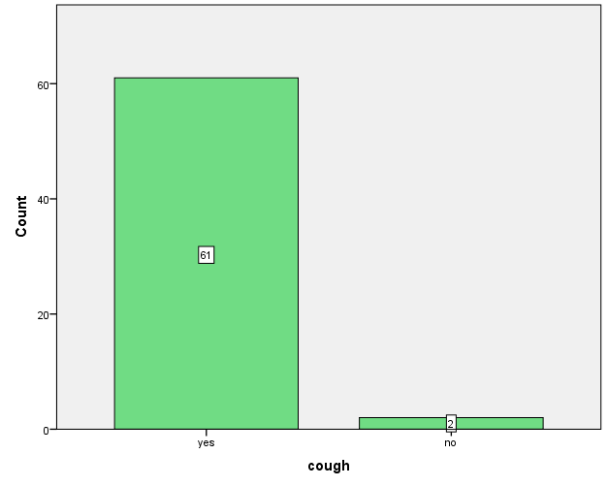
Dyspnoea
 |  | Frequency | Percent | Valid Percent | Cumulative Percent
Valid | Yes | 57 | 90.5 | 90.5 | 90.5
 | no | 6 | 9.5 | 9.5 | 100.0
 | Total | 63 | 100.0 | 100.0
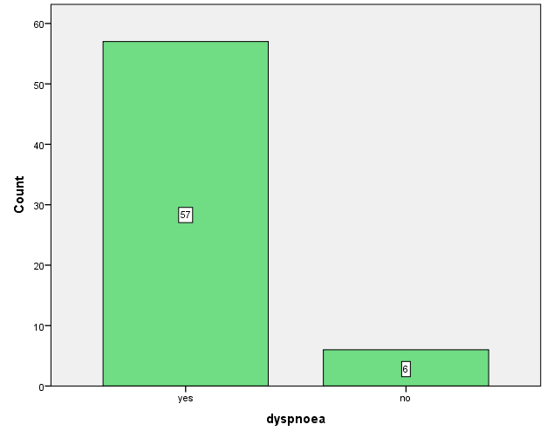

Sputum
 |  | Frequency | Percent | Valid Percent | Cumulative Percent
Valid | Yes | 48 | 76.2 | 76.2 | 76.2
 | No | 15 | 23.8 | 23.8 | 100.0
 | Total | 63 | 100.0 | 100.0
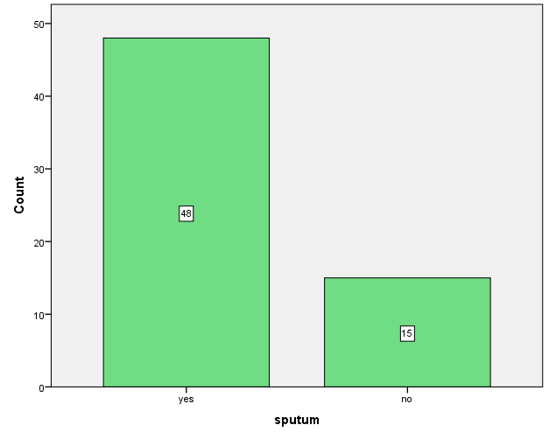
Heamoptysis
 |  | Frequency | Percent | Valid Percent | Cumulative Percent
Valid | Yes | 4 | 6.3 | 6.3 | 6.3
 | No | 59 | 93.7 | 93.7 | 100.0
 | Total | 63 | 100.0 | 100.0
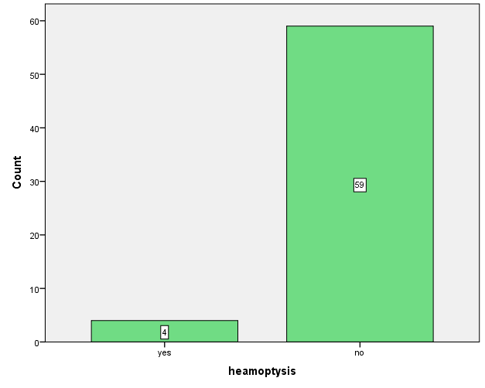

Chestpain
 |  | Frequency | Percent | Valid Percent | Cumulative Percent
Valid | Yes | 33 | 52.4 | 52.4 | 52.4
 | No | 30 | 47.6 | 47.6 | 100.0
 | Total | 63 | 100.0 | 100.0

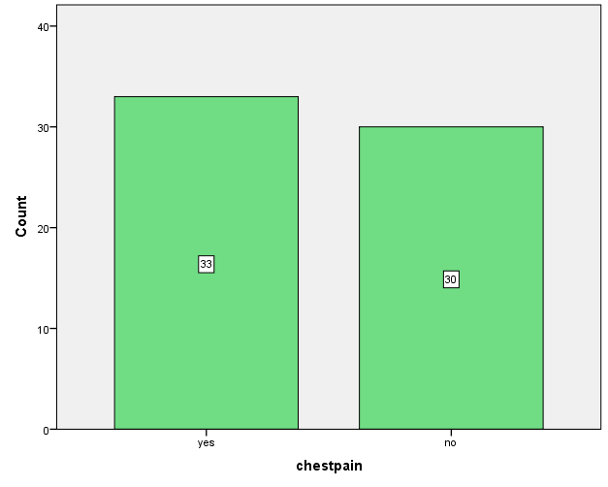

CONCLUSION
Acorrding our result there is strong correlation between certain risk factors and clinical presentation of chronic obstructive pulmonary disease (COPD)..
Our result found as copd most common in older age patient , also the male more than female ,the patient lives in rural area more than those in urban area ,
Also the somking is commonest risk factor and increase risk with increase the pack per year .

The most patient presented with cough,dyspnea and sputum prroduction ,but very little patient presented with heamoptysis ,and some patient presented with chest pain and some without.
DISCUSSION
Exacerbations of chronic obstructive pulmonary disease (COPD) are a leading cause of admission to hospital among patients in many countries, although the factors causing exacerbations are largely unknown. The association between readmission for a COPD exacerbation and a wide range of modifiable potential risk factors, after adjusting for sociodemographic and clinical factors, has been assessed.
We compared these results with another researches in Global initiative for chronic obstructive lung disease
The clinical presentation of COPD is likely changing. After more than 200 years, its cardinal symptoms remain cough, phlegm, and dyspnea . In the 19th century, the diagnosis of COPD, formerly known as emphysema and bronchitis, depended on symptoms, signs of a hyperinflated chest, and reduced expiratory
breath sounds. The airflow obstruction evident on spirometry was identified in that century, but did not enter into clinical practice until much later. Cigarette smoking only became recognized as its dominant cause in the last half of the 20th century. Yet the COPD-contributing phenotypes in the remainder of the 21st century will be different than the blue bloaters and pink puffers observed one or two generations ago.

Dyspnea ,cough and/or sputum production are the most frequnt symptoms ,symptoms are commonly under reported by patients.
Tobacco smoking is the main risk exposure for copd, but environmental exposure such as biomass fuel and air pollution mayy contribute . besides axposure,host factors( gentic abnormalities, abnormal lung development and accelerated aging ) predispose individuals to develop COPD.

References

1- Mathers CD, Loncar D. Projections of global mortality and burden of disease from
2002 to 2030. PLoS Med 2006;3:e442.
2 -British Thoracic Society and the Primary Care Respiratory Society UK. IMPRESS Guide
to the relative value of COPD interventions 2012.
3 -T ّnnesen P. Smoking cessation and COPD. Eur Respir Rev 2013;22:37–43.
4- Department of Health. An Outcomes Strategy for Chronic Obstructive Pulmonary
Disease (COPD) and Asthma in England. London, 2011.
5- C hung LP, Lake F, Hyde E, et al. Integrated multidisciplinary community service
for chronic obstructive pulmonary disease reduces hospitalisations. Intern Med J
2016;46:427–34.
6- C risafulli E, Costi S, Luppi F, et al. Role of comorbidities in a cohort of patients with
COPD undergoing pulmonary rehabilitation. Thorax 2008;63:487–92.
7- Hersh CP, DeMeo DL, Al-Ansari E, et al. Predictors of survival in severe, early onset
COPD. Chest 2004;126:1443–51.
8- Puhan MA, Gimeno-Santos E, Scharplatz M, et al. Pulmonary rehabilitation following
exacerbations of chronic obstructive pulmonary disease. Cochrane Database Syst Rev
2011;10:CD005305.
9- A gusti A, Sobradillo P, Celli B. Addressing the complexity of chronic obstructive
pulmonary disease: from phenotypes and biomarkers to scale-free networks, systems
biology, and P4 medicine. Am J Respir Crit Care Med 2011;183:1129–37.
10- L ange P, Celli B, Agustي A, et al. Lung-function trajectories leading to chronic
obstructive pulmonary disease. N Engl J Med 2015;373:111–22.
11- McGarvey LP, John M, Anderson JA, et al. Ascertainment of cause-specific mortality in
COPD: operations of the TORCH Clinical Endpoint Committee. Thorax 2007;62:411–5.
12- Patel MS, Natanek SA, Stratakos G, et al. Vastus lateralis fiber shift is an independent
predictor of mortality in chronic obstructive pulmonary disease. Am J Respir Crit Care
Med 2014;190:350–2.
13- Swallow EB, Reyes D, Hopkinson NS, et al. Quadriceps strength predicts mortality
in patients with moderate to severe chronic obstructive pulmonary disease. Thorax
2007;62:115–20.
14- Marquis K, Debigaré R, Lacasse Y, et al. Midthigh muscle cross-sectional area is a
better predictor of mortality than body mass index in patients with chronic obstructive
pulmonary disease. Am J Respir Crit Care Med 2002;166:809–13.
15- | Rose G. Sick individuals and sick populations. Int J Epidemiol 1985;14:32–38.  Crossref, Medline, Google Scholar
16. | Blanc PD, Menezes AM, Plana E, Mannino DM, Hallal PC, Toren K, Eisner MD, Zock JP. Occupational exposures and COPD: an ecological analysis of international data. Eur Respir J 2009;33:298–304.  Crossref, Medline, Google Scholar
17. | Ezzati M, Hoorn SV, Rodgers A, Lopez AD, Mathers CD, Murray CJ; Comparative Risk Assessment Collaborating Group. Estimates of global and regional potential health gains from reducing multiple major risk factors. Lancet 2003;362:271–280.  Crossref, Medline, Google Scholar
18. | Stoller JK, Aboussouan LS. α₁-Antitrypsin deficiency. Lancet 2005;365:2225–2236.  Crossref, Medline, Google Scholar

