Structure of microcirculation and capillary system

Each artery entering the organ branches six to eight times before it becomes smaller when it will form what is called arteriole. Arteriole has a diameter less than 20 micro meter, it is highly muscular, they will divide many times to form the capillaries. Separated from the later by what is called precapillary sphincter, after that the blood will collect within another muscular structure that is called venule which is larger than arteriole with less pressure.
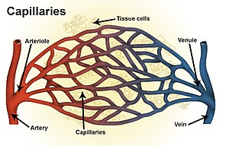
Capillary is composed of endothelial cells (single layer) surrounded by basement membrane has a diameter of 4-9 micrometer. In between the endothelial cells there is a small space that is called the intercellular cleft. Has a width of 6-7 nanometer which is smaller than the diameter of an albumin molecule.
All water and most of the water soluble substances, ions and solutes diffuse rapidly through these cleft, in some places the junction between the endothelial cells is so tight as needed by the organ ( blood brain barrier). Or the junction is so wide as in the liver.
Lipid soluble substances can diffuse directly through the cell walls of the capillary endothelium.
Water soluble substances can diffuse only through the intercellular cleft.
Water of the plasma is exchanged within the water of the interstitium 80 times before the plasma can go the entire distance through the capillary.
Interstitial fluid
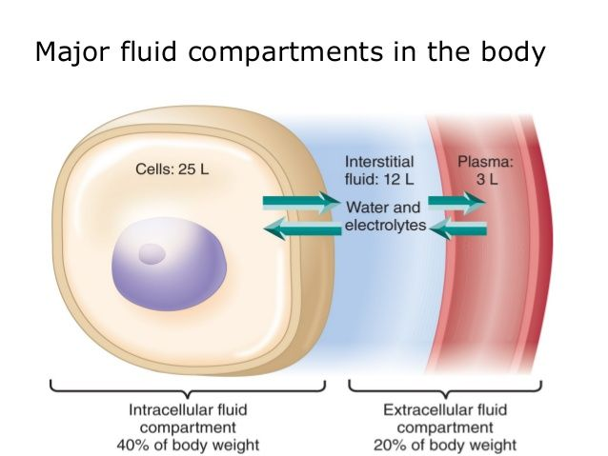
About on sixth of the body consist of spaces between the cells which collectively are called interstitium, it consists of
1.collagen fibers
2.proteoglycan
3.fluid tramped within them.
Combination of 2 and 3 is called tissue gel.

Fluid movement through the capillary membrane
1.capillary pressure(Pc): tend to force the fluid out ward through the capillary membrane.
2.interstitial fluid pressure(Pif): tend to force fluid inward through the capillary membrane when Pif is +ve and outward when Pif is _ve.
3. plasma colloid osmotic pressure (IIp): tends to cause osmosis of fluid inward through the capillary membrane.
4.interstitial fluid colloid osmotic pressure (IIif) which tend to cause osmosis of fluid outward through the capillary membrane.
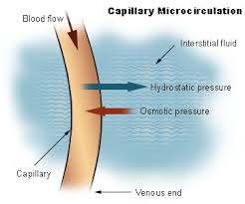
About 80% of the total colloid osmotic pressure of the plasma result from the albumin fraction, 20%from the globulin and 0% from the fibrinogen.
Lymphatic system represent an accessory route by which fluid can flow from the interstitial space into the blood.
Starling equilibrium for capillary exchange
(Under normal conditions a state of near equilibrium exists at the capillary membrane whereby the a mount of the fluid filtering outward from some capillaries equal almost exactly the quantities of the fluid that returned to the circulation by absorption through other capillaries).

Slight disequilibrium that dose occur accounts for the small amount of fluid that eventually returned by the way of the lymphatic.
Edema
Excess fluid in the tissue, it can occur mostly in the extracellular compartment but can also occur in the intracellular compartment.
Intracellular edema:
Caused by
1.depression of the metabolic system of the tissue.
2.lack of adequate nutrition to the cells when blood flow to the tissue is decreases the delivery of O2 and nutrient is reduced, then the cell membrane ionic pump become depressed. Na ions that leaks into the interior of the cell can no longer be pumped out the cells and the excess Na ions inside the cell cause osmosis of water into the cells increase intracellular volume of a tissue area.
In inflammatory state, intracellular edema can occur due to increase membrane permeability of Na and other nutrient intracellularly with subsequent osmosis of water into the cells.
Extracellular edema
Caused by
1.abnormal leakage of plasma fluid from the capillary to the interstitium.
2.failure of lymphatic to return fluid back to the circulation, which mean large amount of the proteins will remain in the lymphatic and in the interstitium.

Causes of edema:
I. increase capillary pressure:
a. excessive kidney retention of water and salt.
1.acute or chronic kidney disease.
2.mineralocorticoid excess.
b.high venous pressure
1.heart failure.
2.venous obstruction.
3.Failure of venous pump.
--muscle paralysis
--immobilized parts of the body
--failure of venous valve
decrease arteriolar resistance
1. excess body heat
2. insufficiency of sympathetic nervous system.
3. vasodilator drugs

II. decrease plasma protein
1.loss of protein in the urine.
2.loss of protein in the urine( burn or wound)
3.failure to produce protein( liver disease or on protein malnutrition)

III. increase capillary permeability
1.toxins
2,bacterial infection.
3. prolonged ischemia
4.burn
5. immune reaction.
IV. Blockage of lymphatic return
a.cancer
b.infection
c.congenital absence
d.surgery

edema caused by heart failure
---this leads to increase venous pressure and capillary pressure.
---Decrease excretion of salt and water by the kidney.
---Increase capillary hydrostatic pressure
--Hormonal changes leads to increase renin and angiotensin hormon--

Edema caused by kidney disease
Retention of salt and water---
---Increase interstitial fluid volume
---Cause hypertension which leads to increase hydrostatic pressure.

Edema caused by liver diseases
---Decrease protein formation
---Decrease osmotic colloid pressure
---Increase hormones like aldosterone

