L4
Drug therapy is usually reserved for patients with high risk of complications from obesity and its optimum timing and duration are controversial.
There is evidence that those patients who demonstrate early weight loss (usually defined as 5% after 12 weeks on the optimum dose) achieve greater and longer-term weight loss, and this is reflected in most guidelines for the use of drugs for obesity.
Treatment can be stopped in non-responders at this point and an alternative treatment considered.
Although life-long therapy is advocated for many drugs that reduce risk on the basis of relatively short-term research trials (e.g. drugs for hypertension and osteoporosis), some patients who continue to take anti-obesity drugs tend to regain weight with time; this may partly reflect age-related weight gain, but significant weight gain should prompt reinforcement of lifestyle advice and, if this is unsuccessful, drug therapy should be discontinued
Surgery
- ‘Bariatric’ surgery is by far the most effective long-term treatment for obesity and is the only anti-obesity intervention that has been associated with reduced mortality.
- Bariatric surgery should be contemplated in motivated patients who have very high risks of complications of obesity, when extensive dietary and drug therapy has been insufficiently effective.
It is usually reserved for those with :-
- Severe obesity (BMI > 40 kg/m2 )
- Those with a BMI > 35 kg/m2 and significant complications, such as type 2 diabetes or obstructive sleep apnoea
- Some evidence-based guidelines now suggest surgery can be considered at a lower weight in people with recent-onset diabetes and a BMI > 30 kg/m2
- Only experienced specialist surgeons should undertake these procedures, in collaboration with a multidisciplinary team. Several approaches are used and all can be performed laparoscopically. What is the mechanism ????
- The mechanism of weight loss may not simply relate to limiting the stomach or absorptive capacity, but rather in disrupting the release of ghrelin from the stomach or promoting the release of other peptides from the small bowel, thereby enhancing satiety signalling in the hypothalamus
Diabetes may improve rapidly after surgery, particularly after gastric bypass, and although this may be attributed to severe energy restriction in the perioperative period, it is possible that increased release of incretin hormones such as GLP-1 may contribute to the improvement in glucose control.
Complications depend on the approach.
- Mortality is low in experienced centres but post-operative:- Respiratory problems
- Wound infection and dehiscence
- Staple leaks
- Stomal stenosis
- Marginal ulcers and venous thrombosis may occur.
Additional problems may arise at a later stage, such as:
- Pouch and distal oesophageal dilatation
- Persistent vomiting, ‘dumping’
- Hypoglycaemia and
- Micronutrient deficiencies, particularly of folate, vitamin B12 and iron, which are of special concern to women contemplating pregnancy; this should be delayed for at least 2 years following surgery.

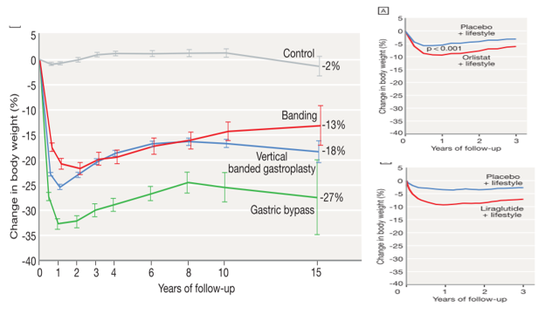

Treatment of additional risk factors
Obesity must not be treated in isolation and other risk factors must be addressed, including smoking, excess alcohol consumption, diabetes mellitus, hyperlipidaemia, hypertension and obstructive sleep apnoea.
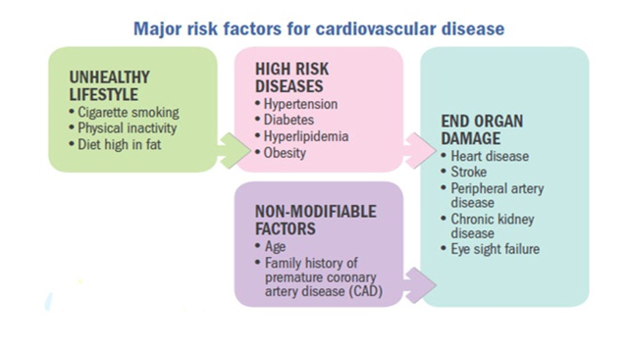

Under-nutrition Starvation and famine
There remain regions of the world, particularly rural Africa, where under-nutrition due to famine is endemic, the prevalence of BMI of less than 18.5 kg/m2 in adults is as high as 20%, and growth retardation due to under-nutrition affects 50% of children.
The World Health Organisation (WHO) reports that chronic under-nutrition is responsible for more than half of all childhood deaths worldwide.
Starvation is manifest as marasmus (malnutrition with marked muscle wasting) or, when additive complications such as oxidative stress come into play, malnourished children can develop kwashiorkor (malnutrition with oedema).
Growth retardation is due to deficiencies of key nutrients (protein, zinc, potassium, phosphate and sulphur).
In adults, starvation is the result of chronic sustained negative energy (calorie) balance.

Clinical features
In starvation, the severity of malnutrition can be assessed by anthropometric measurements, such as BMI. Demispan and mid-arm circumference measurements are most useful in monitoring progress during treatment.
Under-nutrition often leads to vitamin deficiencies, especially of thiamin, folate and vitamin C.
Diarrhoea can lead to depletion of sodium, potassium and magnesium.
The high mortality rate in famine situations is often due to outbreaks of infection, such as typhus or cholera, but the usual signs of infection may not be apparent. In advanced starvation, patients become completely inactive and may assume a flexed, fetal position. In the last stage of starvation, death comes quietly and often quite suddenly. The very old are most vulnerable. All organs are atrophied at necropsy, except the brain, which tends to maintain its weight

Clinical features of severe under-nutrition in adults
• Weight loss
• Thirst, craving for food, weakness and feeling cold
• Nocturia, amenorrhoea or impotence
• Lax, pale, dry skin with loss of turgor and, occasionally, pigmented patches
Cold and cyanosed extremities, pressure sores
• Hair thinning or loss (except in adolescents)
• Muscle-wasting, best demonstrated by the loss of the temporalis and periscapular muscles and reduced mid-arm circumference
• Loss of subcutaneous fat, reflected in reduced skinfold thickness and mid-arm circumference
• Hypothermia, bradycardia, hypotension and small heart
• Oedema, which may be present without hypoalbuminaemia (‘famine oedema’)
• Distended abdomen with diarrhea
• Diminished tendon jerks
• Apathy, loss of initiative, depression, introversion, aggression if food is nearby
• Susceptibility to infections
Investigations
In a famine, laboratory investigations may be impractical but will show that
- Plasma free fatty acids are increased and there is ketosis and a mild metabolic acidosis.
- Plasma glucose is low but albumin concentration is often maintained because the liver still functions normally.
- Insulin secretion is diminished, glucagon and cortisol tend to increase, and reverse T3 replaces normal triiodothyronine.
- The resting metabolic rate falls, partly because of reduced lean body mass and partly because of hypothalamic compensation.
- The urine has a fixed specific gravity and creatinine excretion becomes low.
- There may be mild anaemia, leucopenia and thrombocytopenia. The erythrocyte sedimentation rate is normal unless there is infection.
- Tests of delayed skin hypersensitivity, e.g. to tuberculin, are falsely negative.
- The electrocardiogram shows sinus bradycardia and low voltage.
- Infections associated with starvation
- • Gastroenteritis and Gram-negative sepsis
- • Respiratory infections, especially bronchopneumonia
- • Certain viral diseases, especially measles and herpes simplex
- • Tuberculosis
- • Streptococcal and staphylococcal skin infections
- • Helminthic infestations

Management
Whether in a famine or in wasting secondary to disease, the severity of under-nutrition is graded according to BMI.
People with mild starvation are in no danger; those with moderate starvation need extra feeding; and those who are severely underweight need hospital care.
In severe starvation, there is atrophy of the intestinal epithelium and of the exocrine pancreas, and the bile is dilute.
It is critical for the condition to be managed by experts. When food becomes available, it should be given by mouth in small, frequent amounts at first, using a suitable formula preparation .

F-75 is prepared from milk powder (25 g), sugar (70 g), cereal flour (35 g), vegetable oil (27 g) and vitamin and mineral supplements, made up to 1 L with water.
F-100 (1 L) contains milk powder (80 g), sugar (50 g), vegetable oil (60 g) and vitamin and mineral supplements (no cereal).
Individual energy requirements can vary by 30%. During rehabilitation, more concentrated formula can be given with additional food that is palatable and similar to the usual staple meal.
Salt should be restricted and micronutrient supplements (e.g. potassium, magnesium, zinc and multivitamins) may be essential.
Between 6.3 and 8.4 MJ/day (1500–2000 kcal/day) will arrest progressive under-nutrition but additional energy may be required for regain of weight.
During refeeding, a weight gain of 5% body weight per month indicates satisfactory progress..
Other care is supportive and includes attention to the skin, adequate hydration, treatment of infections and careful monitoring of body temperature, since thermoregulation may be impaired.
Circumstances and resources are different in every famine but many problems are non-medical and concern organisation, infrastructure, liaison, politics, procurement, security and ensuring that food is distributed on the basis of need.
Lastly, plans must be made for the future for prevention and/or earlier intervention if similar circumstances prevail.

